2015 - 2016

Nathan Sainsbury (P13202059)

De montfort university

Design and Development of a 2D Multiplayer Online Role-Playing Game (MORPG)

1.0 – Contents

|  |  |
| --- | --- |
| 2.0 Abstract | 3 |
| 3.0 Introduction | 3 |
| 4.0 A review of existing literature | 4 |
| 4.1 Abstract | 4 |
| 4.2 Introduction | 4 |
| 4.3 Understanding the source of the challenges | 5 |
| 4.4 Why are MORPGS at greater risk | 7 |
| 4.5 Solutions in an authoritative client-server architecture | 8 |
| 4.6 Summary | 11 |
| 5.0 Project management | 12 |
| 5.1 The purpose of project management | 12 |
| 5.2 Management methodologies | 12 |
| 5.3 Successes and failures | 13 |
| 6.0 Gameplay design and development | 15 |
| 6.1 The purpose of gameplay design | 15 |
| 6.2 Design considerations | 15 |
| 6.3 Design analysis | 16 |
| 7.0 Technical design & development | 17 |
| 7.1 The purpose of technical design | 17 |
| 7.2 Design documents | 17 |
| 7.3 Design considerations | 18 |
| 7.4 Design analysis | 19 |
| 8.0 Testing | 21 |
| 8.1 The purpose of testing | 21 |
| 8.2 Testing methodologies | 21 |
| 8.3 Test result analysis | 25 |
| 9.0 Project evaluation | 27 |
| 9.1 Project management evaluation | 27 |
| 9.2 Gameplay design evaluation | 27 |
| 9.3 Technical design evaluation | 28 |
| 9.4 Testing evaluation | 29 |
| 9.5 Product evaluation | 30 |

|  |  |
| --- | --- |
| 10.0 Conclusions | 32 |
| 11.0 References | 33 |
| 12.0 Appendices | 35 |
| 12.1 Project management appendices | 35 |
| 12.2 Gameplay design and development appendices | 46 |
| 12.3 Technical design and development appendices | 50 |
| 12.4 Testing appendices | 90 |

2.0 – Abstract

This report aims to review an 8 month university project focusing on the research, planning and execution of the development of a 2 dimensional multiplayer online role-playing game. There are many aspects involved in the production of an MORPG and although each area has been covered in reasonable detail, the primary theme of this report relates more to the technical side than that of the artistic side.

Discussions have been presented against each of the topics associated with the process. Briefly, these topics include: pre-development research, project management, gameplay design, technical design and system testing. Finally, a critical evaluation of the entire projects successes and failures is given with some closing thoughts on the future of this project and those of a similar nature.

3.0 – Introduction

With technology racing ahead in all directions, the ability to craft incredible online worlds that hundreds or even thousands of players can enter and enjoy has started to become a limitation of the imagination rather than that of physical hardware. The production of such a world can range in scale vastly – from 2 dimensional games that won’t remember you the next day to enormous persistent 3D environments with a rich collection of social and gameplay features that take years to complete in full. If there’s one thing these worlds are not however, it is overnight jobs. Multiplayer online role playing games (MORPGs) can take anywhere from a few months to several years to develop and come with some the largest technical and gameplay demands of any genre in the game development industry.

This project aims to explore the themes and processes behind engaging in the development of one of these online worlds. Acknowledgement is given along the way to the hurdles that a project manager, technical director and game designer will need to overcome in order to successfully deliver a finished product. Of course, the creation of a fully-fledged 3d world with data centres, dedicated login servers, SQL databases and internal gameplay production toolchains is slightly beyond the means of a single developer, and so the target of this project resides in a much simpler form: a single server hosting a 2D environment for an estimated 5 to 15 players.

The approach to the project as a whole is similar to that of any other game: Research, plan and develop. The intricacies of each of these processes however is unique in the grounds of MORPGs as each stage must expand its horizons to account for whole new list of traits such as excellent scalability, networked gameplay, multiplayer world immersion and extensive social systems. Care has been taken to address each of these traits as they surfaced throughout their relevant development sections, with the overall aim of turning what could have been a problematic side effect of working in the online space in to a positive technical and gameplay experience for the developer and user alike.

4.0 – A review of existing literature

Before fully committing to the development of the project, research needed to be done to gather and understand the existing information surrounding the topic of MORPGs. A number of different approaches were available with respect to network architecture, but the amount of information available in the authoritative client-server model outweighed that of any other. The following literature review aims to express the discoveries made during the research stage with references to the sources of information and a review of the current and future prospects of the topic as a whole.

# 4.1 Abstract

This study examines the need to incorporate a number of technical strategies in to the design and development of a modern multiplayer online role playing game (MORPG) in order to sufficiently resolve a variety of complex issues that could affect user experience. In particular, the study aims to discuss broad solutions to problems surrounding the areas of system security and control, user scalability and load distribution and game world synchronisation.

The vast majority of this article will look at systems using a client and authoritative server architecture, and will aim to review the topics in that context. Whilst peer-2-peer (P2P) architectures can be suited to role-playing games (RPG), and will be looked at briefly in certain areas of the discussion, they are not the focal point of this review.

# 4.2 Introduction

As more and more developers choose to enter the world of multiplayer online role playing games, the desire to make any individual title stand out from the rest of the crowd grows. With the functional requirements of modern-day RPGs including exciting features such as vehicular and skill-shot (Damien, 2015) orientated combat, player-created housing and multiple methods of communication, the technology powering it all faces an ever expanding list of problems to confront. To make matters worse, an MORPG is often expected to successfully deliver on a large basic feature set before users will even consider experiencing the further features a game has to offer (Burnell, 2016), (Mjamias, 2013).

Naturally, the end-result of creating a successful computer game comes down to providing a good user experience. This is an especially important trait for multiplayer games, as the game world is usually constructed around the idea that it will be populated by at least some number of real players at any given time. As such, losing a portion of a player-base can be considered a much greater loss than in many other types of games. The issues that will be discussed in the main body of this article have, by some means, been extracted from the idea that without finding an acceptable solution, the user experience will be affected in a negative fashion that may cause players to depart from the game entirely.

Whilst on the surface many of the covered issues may seem simple, operating from a single point of authority can result in a number of solutions interacting with each other in ways that may present further complexity. This piece seeks to examine how such a complexity can be reduced or avoided so that it would not present a noticeable impact to the user under normal operating circumstances. It is essential to keep in mind however, that a full and complete answer to a problem often involves an approach from multiple angles, whereas this review only works to discuss the architectural component of the complete answer.

# 4.3 Understanding the source of the challenges

MORPGs and their similarly named large scale version MMORPGs (Hughes, n.d.) both suffer from a series of technical challenges that are a result of the desire to provide and protect an engaging online multiplayer gaming experience. For the most part the problems discussed are not the fault of the design of the particular game in question but rather are inherent to operating in the online multiplayer space. A notable consideration to make before moving on to the list of problems is the impact of each problem on each individual game as certain games are more likely to feel the effect of the issue at hand than others. For as long as development time is a finite currency, so too will be the maintainability, completeness and extendibility of the given solution(s).

## 4.3.1 Network load

Network load is the most obvious constraint when discussing games that take place in an online world. There is no avoiding the fact that every player that is connected to the server must be able to send and receive enough information to be able to rebuild the relevant parts of the game state on their end of the connection. Whilst sending updates from the client to the server can be trivial, receiving them is significantly more complex and requires a number of strategies that aim to improve the efficiency of merging multiple client updates together as well as reducing the amount of data that needs to be returned to the client. Without any reduction strategies at all, the amount of data that needs to be communicated with each client is equal to the square of the number of connected players.

## 4.3.2 Network security

Network security is an incredibly taxing challenge and refers to the need to prevent users from misusing the data exchanges between the client and server for their own personal benefit. The effect of sending data that the server is not expecting varies, with consequences ranging from a player receiving in-game items they would otherwise not be able to all the way to the client gaining administrator access to the server controls. Naturally such an incident is to be avoided at all costs as the effect on the user experience could be devastating – especially in the latter situation where gameplay could be disrupted. Most commonly, players that commit these offenses are referred to as “hackers” and are typically disallowed access to the game once they are caught.

## 4.3.3 Network latency

Network latency is becoming a bigger and bigger issue for gamers in the modern era. Frequently referred to as “lag” (Bernier, 2001), network latency is the result of the need for network data to physically move from one location to another over the internet and is an impossible issue to avoid. Further complicating the issue is the need for all clients to connect to the same server cluster (in one location) whilst simultaneously being in many different geographical locations themselves. This creates a negative gameplay experience where those who happen to live nearer to the servers experience an advantage over those who live further away or in countries with poor internet connectivity. The importance of reducing lag also varies depending on the mechanics and expected level of competitive gameplay. Take Riot Games’ League of Legends (Riot Games, 2016) for example – a multiplayer online battle arena (MOBA) (Wikipedia, n.d.) game that recently launched its own internet network designed to provide faster connectivity for video game traffic as a result of the demand to be able to play in a near real-time setting (Maynard-Koran, 2016).

## 4.3.4 Sense of achievement

Whilst a sense of achievement is not directly a technical challenge, it is worth mentioning in respect to the additional technical requirements it presents. It is extremely common for MORPGs to contain a number of progression or achievement orientated gameplay mechanics as they are used to hook players in to the game and keep them interested (Nicolas Ducheneaut, 2006). In order to ensure a sense of achievement is conveyed to a set of players, a series of gameplay barriers must be presented and upheld that differentiate a successful player from a less successful player. Such barriers can be removed in situations where a player is able to bypass a game mechanic through cheats or exploits that were otherwise unintended, which in turn makes players who already possess such achievements feel less successfully relative to their peers.

## 4.3.5 Gameplay automation

Gameplay automation almost certainly becomes an issue for any modern day MORPG as crafty players seek to gain advantages over each other by using 3rd party programs to play the game for them at times that they would otherwise not want or be unable to do so. In the vast majority of games, a terms of service (ToS) agreement is provided that prohibits exactly this kind of automated gameplay(ArenaNet, 2016)(Jagex, 2016)(NCSoft, 2016).

*A. use cheats, automation software (bots), hacks, mods or any other unauthorized third-party software designed to modify the World of Warcraft experience;* (Blizzard Entertainment, 2016)

This kind of behaviour is difficult to prevent as the disallowed actions takes place on the client side and the solution is a multi-step process involving data collection, software patching and banning or restoring of the affected players account(s). Particular activities performed by bots include automatically collecting resources, dodging skill-shots with inhuman reaction speeds and providing information to the user that is typically not accessible via the user interface.

## 4.3.6 Gameplay exploits

A gameplay exploit is the result of a bug in the software of either the client or server that presents access to a player to an unintended effect within the game or game world. Similarly to gameplay automation, most ToS agreements have a clause that state that these exploits may not be abused or publicized amongst other players.

*1. You will not exploit any bug in Guild Wars 2 and you will not communicate the existence of any such exploitable bug (bugs that grant the user unnatural or unintended benefits) either directly or through public posting, to any other user of Guild Wars 2.* (ArenaNet, 2016)

This kind of challenge is almost inevitable and scales proportionally with the numbers of players and the number of mechanics present within the game world. As such, protecting the user experience usually becomes a matter of having a reliable means of reversing the unfair gains that players who utilised the exploit gained as well providing some method of forwarding the information relating to the exploit to the development team.

## 4.3.7 Content control

Content control is a problem much more unique to that of MORPGs and stems from the need for constant interaction with the game world by the game administrators or “game masters (GMs)” as they are better known in the industry (Anders Tychsen, 2005). The game masters are often provided a selection of tools such as scripts, debug tools and account control tools that allow them to resolve issues that occur within the game that the developers are not able to attend to in good time. As the power of such tools extends far beyond that of a standard player, the tools need to be developed and deployed with respect to a set of permissions that limits who can use them.

# 4.4 Why are MORPGs at greater risk?

With all these issues identified, what is it exactly that puts a multiplayer role playing game at higher risk of problems than that of another genre? Indeed, an RPG is not the only kind of game that may take place in the online space, and all other genres become the victim of most of the issues listed to some degree, so what specifically causes an RPG to falter?

## 4.4.1 In-game events

Events are a series of in-game activities that take place over a limited period of time and tend to attract a large number of players to a minimal number of locations within a game world. These events tend to be very common among role-playing games as they are used to progress the story of the game in a globally engaging manner (Braithwaite, 2015). The issue that arises from developing and activating such events is that the influx of players in to a subset of locations typically results in the servers hosting those areas experiencing significant performance degradation.

One of the most famous events to ever take place was the Ahn’Qiraj Opening Event from World of Warcraft (WoWPedia, n.d.) in 2007. The event caused numerous server crashes and several hour long login queues for players trying to get involved in the event simply due to the sheer number of players participating. In the modern day, such technical issues are deemed largely unacceptable and quickly bring about negative user experience reports.

## 4.4.2 MORPG players play for a long time

Gamers are known for their tendency to play their favourite games for many hours at a time – and online RPGs are no different. Studies have found that many players spend extended periods of time logged in to their favourite game worlds and modern RPGs are unlikely to avoid having to acknowledge this. To make matters worse, large-scale multiplayer games often divide their servers in to regional sections that take place across multiple time zones. Combining the peak usage hours of a variety of countries and the extended playing sessions of RPG players – it is easy to see why a server may need to be capable of handling a heavy network load for many hours at a time (Yee, n.d.) (Yee, 2004).

## 4.4.3 Cities and the open world

It is extremely common for an online role-playing game to host a number of cities where a large group of players will meet up to exchange in-game goods and services. Cities are traditionally a focus point of any game and bare host to a large number of game features that would not otherwise be accessible, such as crafting, trading and city-wide communication.

Additionally, a number of these games choose to model their world in an open-world format, meaning that each area flows straight in to the next without any form of loading screen. For games that choose to do this, determining which node is in charge of processing any one group of players becomes increasingly complex. Guild Wars 2 (ArenaNet, 2015) is an example of an MMORPG that chooses not to do this, instead opting for a ‘one processor per zone per server’ methodology.

## 4.4.4 Character customisation

Whilst not a major factor, the degree to which character customisation has improved over the past few years has made it a noticeable drain on network performance. The amount of data a character may possess and the number of other players who can see that character are directly related to an increase in network traffic as more data is required to accurately rebuild the visuals on each client.

MORPGs are particularly guilty of excessive character customisation and often provide a method for modifying a characters body, face, armour, effects and various other additional visual attachments. Some games resolve this issue by reducing the level of detail (LoD) of characters as they become further away from the player.

# 4.5 Solutions in an authoritative client-server architecture

There are a vast variety of solutions available for each technical challenge presented by the design and development of an MORPG. However, complication arises when the time comes to choose which solution best fits an individual game as functional requirements vary greatly from system to system. The solutions that have been proposed below aim to remain as generic as possible whilst still providing useful information and suggestions with respect to their sub-category. It is also worth noting that some challenges require tackling from multiple angles, and so solutions will have a tendency to overlap in some areas – particularly in regard to network optimisation.

## 4.5.1 Security

System security is a constant game of cat and mouse between the developers of an MORPG and the less than desirable player base that chooses to break the rules. Without sufficient technical defences, a multiplayer game quickly becomes overrun by players cheating or leaving as they succumb to the effects of those around them putting them at a disadvantage. As such, it is important for all modern day MORPGs that wish to maintain control over their game worlds to implement a series of barriers that minimise and prevent common methods of disrupting fair gameplay. This is especially important when consideration is made for previous studies that show just how much cheating influences player satisfaction.

*Of all the issues, “Exploits, Cheats and Item Duping” was selected by 100 (82%) of the 122 respondents’ as one of the top five issues; it was also most frequently ranked as the number one issue. Considering this, developers should be extremely careful and implement security measures to stop players from exploiting the game system to gain unfair advantage over other players.* (Leigh Achterbosch, 2007)

### 4.5.1.1 Bot detection

Bot detection is one of the most challenging components of building a secure system as preventing a player from tampering with any component of a game that is handed over to them eventually reaches a level at which it becomes impossible. For the most part, players can be deterred from tampering by emplacing a series of barriers such as those found in Blizzard Entertainments anti-cheat software “Warden”. The software uses a mixture of techniques to detect and ban users who are misbehaving such as scanning active processes for known hacking/botting programs; periodically comparing the hashed version of memory addresses within the game client with their server equivalents and disconnecting the user should the client stop sending hash values to the server (HackMag, 2016) (McGraw, 2005). The use of client and server comparisons here is the important concept to take away as it presents a reliable means of defending against standard botting behaviour.

### 4.5.1.2 Client trust

As a general rule trusting the client in a client and server setting is never the right thing to do as it introduces a means of deceiving the server in to performing invalid actions. Unfortunately, as the scale of a game increases, the ability for the hosting hardware to authorise each and every decision arriving from all currently active users becomes unbearable. Resultantly, recent trends have given over some of the authority of the server to the client, enabling it to make decisions that could potentially be against the rules of the game. If used carefully and in conjunction with appropriate activity logging and bot detection, gameplay can remain mostly unaffected even in the event that a player misuses their client’s newfound power. Specific examples include allowing a player to send position updates to the server that are blindly trusted within a set of boundaries and permitting a player to modify their local copy of their statistics within notifying the server.

## 4.5.2 Control

### 4.5.2.1 GM Tools

Game master tools in an authoritative server environment are much easier to implement than in a P2P architecture as the verification of the permissions to use the tools can be limited to a single location strictly controlled by the developer. The implementation of these tools should be done in such a way that a game master is able to resolve almost any in-game or account based conflict within needing to refer to a developer or higher-up within the live maintenance team. Such tools are typically built with some form of scripting language and are accessed via a custom user interface built for game master accounts only (Anders Tychsen, 2005). Unfortunately information regarding this subject is scarce as these toolchains tend to be proprietary software for in-house use only.

## 4.5.3 Network load distribution & scalability

### 4.5.3.1 Area of interest & world divisions

Dividing up the game world in to small sections and allocating an “area of interest” (AOI) to a user is a common and well-researched method of alleviating load and scalability issues (Olof Hagsand, 1997). The area of interest refers to the area surrounding a player that would contain game world updates that the player would be interested in and is dynamically positioned relative to the user and their movements. The topic has been expanded on in recent years, with suggestions being made to implement a priority system on top of the AOI’s that determine the rate at which updates are harvested from those regions (Yang-Wai Chow, 2005).

### 4.5.3.2 Update packing

Update packing is a strategy that involves preventing the transmission of updates across a network for a period of time such that updates are allowed to accumulate before they are sent. The main idea behind this strategy is to avoid scenarios where a user who may need to receive more than 1 update in a single server game loop is sent more than the necessary number of data packets to communicate those updates. Instead, instructions are packed in to a single packet and posted once every game loop. Packing also opens up opportunities for applying compression algorithms to further minimise network traffic and improve scalability (Wang Jianmin, 2010).

### 4.5.3.3 Load distribution

Load distribution involves the use of multiple servers to receive, process and forward updates to players who are interested in them. The way in which the servers are connected is referred to as a network topology and can be designed in a variety of ways to best suit the system that is being built. One proposed system involved the use of an arbitrary number of servers that were responsible for hosting clients rather than zones within the game world. Events would then be handled by having the servers determine who was interested in the event using the information they stored about their connected clients (Funkhouser, 1996). More recent work has moved towards finding ways to divide up a game world in to regions that are processed by a single server each. Such an architecture can be used to scale with the size of a game with relative simplicity, and provides a simple means of culling a large portion of network traffic amongst clients and servers (Marios Assiotis, 2006).

## 4.5.4 Game synchronization

### 4.5.4.1 World synchronisation

Game world synchronisation is both a client and server issue that can be resolved in a number of ways. The client portion of the synchronisation refers to the need to retrieve updates from the server relative to the activities the user is engaging in currently. One method of doing this is to calculate a viewing vector that the server can use to determine the updates to send back to the client (Sherinian, 2014). Another method of client side synchronisation is to use a form of client-side prediction to compensate for down-time in network communications. This approach typically permits a player to drift out of sync with the server slowly, but with constant ‘corrections’ being downloaded from the server (Bernier, 2001).

The server component of the synchronisation problem refers to the need to ensure consistency amongst the game state of all servers currently processing a single location; or the need to transfer updates from one server to another. One such network topology that supports this kind of behaviour is the proxy server network topology: an interconnected mesh of servers that each replicate a single game state to feed to their connected clients (Jens Muller, 2004).

### 4.5.4.2 Latency compensation

Latency (or “lag”) compensation is a method of client side prediction that handles delay in communications transfers by offsetting the communicated data by a value relative to a player’s latency. Using this method, players do not have to account for latency in their own decision making and can instead engage in the game world as if the world were in real time (Bernier, 2001).

Fortunately MORPGS were found to have a very high threshold of playability when dealing with latency, meaning that while still an important feature of any modern game, a less-than-perfect compensation methodology would not be the end of a games livelihood.

*The game expectedly turned out to be non-playable at very high latency sequences. The “breakpoint” (point from where the game was no longer fluently playable) however occurred at 1250ms, which was more than two times higher than expected.* (Tobias Fritsch, 2005)

## 4.6 Summary

The first and most notable conclusion, and a constant theme throughout all relevant literature, has been the necessity of maintaining a strong grasp on the actions that users can and cannot perform. In this respect, most MORPGs simply could not function in a P2P or non-authoritarian server environment as the introduction of even a single rogue player can bring the game to its knees with a great deal of ease. Literature suggests that in an ideal situation, a server would have complete and total control over each and every decision that a client makes with regard to the game world. Of course, basic laws of physics stand firmly in the way in the form of networking and thus sacrifices must be made in order to provide a good user experience. The debate over just how much authority should be sacrificed to the client varies greatly, with some systems preferring to ban players in response to bad behaviour and some preferring to prevent the behaviour entirely.

The second conclusion drawn from this research has been the importance of accurate game world synchronisation through a combination of techniques such as movement prediction and advanced client side collision detection and resolution. Whilst the implementation of movement prediction is almost entirely beneficial (especially when it can be toggled off on the client side), performing collision detection and resolution on the client side as well as the server side can suffer playability issues when latency is involved.

Another conclusion is the exceptional important of protecting an MORPGs sense of achievement by minimising the effect that players who break the rules have on other players. In several instances, players have alluded to the fact that their status within a game, particularly one of an RPG nature, is key to their enjoyment and desire to continue playing. Resultantly, strategies such as bot detection and exploit reversal are unavoidable necessities for any modern gaming world.

A final conclusion that could be drawn from this review was the benefits of minimizing server load by dividing up a game in to smaller sections and offloading each section on to separate hardware. Whilst this is unlikely to be necessary for MORPGs that only serve player counts in the hundreds, current technology begins to falter when introduced to thousands of users engaging in concurrent play. This is particularly important in games that contain complex mechanics that need to be constantly authorised during client-server communications.

There is still a great deal of research to be done and this paper only touches on the surface of finding the optimal solutions in these subject areas. Many areas could be investigated much further, with a greater focus on one particular implementation rather than tackling an array of issues all at once.

One such investigation area that could be recommended is a more in-depth look at network synchronised collision detection and resolution systems – an important subject for creating the perception of highly responsive gameplay – especially as more and more games move towards the use of skill-shot orientated combat.

Another extended suggestion could be a LoD prediction system that aims to reduce network load by predicting the details of a dynamic environment based on previously known information.

A final suggestion would be to step further in to the realm of networking and explore the work Riot Games is doing with building their own internet network. With gaming still surging in popularity, and lag still being a burden on gameplay experience, it could be useful to research the use of a more “game-friendly” internet protocol.

5.0 – Project Management

## 5.1 – The purpose of project management

Project management was an essential component of the overall project that implemented a variety of strategies to help ensure the success of each task as and when they needed to be completed. The main reasons for using these strategies were to provide guidance throughout the duration of the development cycle and to assist in the re-evaluation of the progress that was being made on a week by week basis. Specifically, a good set of management techniques helps to break down the project in to smaller chunks and assigns those chunks an order of completion such that they can be better tracked from start to finish. Tracking of the overall progress in this way can also be used to solve issues with delays as they arise and also presents opportunities to revisit the design of software components as it is deemed necessary.

## 5.2 – Management methodologies

The decisions of which management methodologies to use were made at the very beginning of the project before the system design and development commenced. The decisions to be made included: Which design and development paradigm would be used, which documents should be produced and how the code should be versioned.

A number of options were available for which design paradigm should be used, each with their advantages and disadvantages. The waterfall model deserves mentioning for the amount of time it has been around, but it is largely incompatible with this project as it provides no flexibility for adding, removing or reworking features as the need arises. Another model that was evaluated for usefulness in this project was the rapid application development (RAD) model. This model focuses on iteratively building on the entire system via prototypes until the application meets all of the functional requirements. This issue here however is that a large number of the systems required for the project depend on the completion of other components and the completion of themselves to function even remotely close to correctly. Ultimately the paradigm that was put in to practice was the agile paradigm as it would provide the best balance between careful design and iterative development. Whereas the focus of RAD would be on developing the entire system, the agile approach allowed for the iterative development of subsystems and readjustment of the overall design with less restriction.

The decision of which project documents to write seemed fairly obvious at start. At least one method of managing the order in which tasks should be completed and at least one description of the requirements of the final product needed to be produced.

For the order of tasks, a Gantt chart was produced that outlined the task that needed to be completed each week and also outlined the component of the system that the task belonged to. As the development period of the project was quite short, the timing division used for the creation of the chart was half a week.

For the definition of the tasks that needed to be completed, a functional requirements specification was produced that outlined the high-level client and server functionality that would be required in order to create the final game. Other options such as user stories were available, although it did not seem appropriate to use them as they are more suited for describing the requirements of a third party rather than the sole developer.

Source code management was another management technique that needed to be addressed before beginning development. There is no real reason in any modern day project not to be using some form of source management program as they are both freely available and could end up saving a project from a lengthy surprise delay. The two clear options that were available were GitHub, an ‘everyone has their own local copy with a single remote master copy’ style of source control, and SVN, a ‘single remote master copy with checking in and out system’ style of control. The decision was made to use the former, as the software was already known and committing to the master copy would be less of an issue in a one-man project.

## 5.3 – Management successes and failures

As briefly mentioned above, one of the biggest failures of my project management strategy was the inclusion of a Gantt chart [12.2.2] instead of a burndown chart for managing the order in which tasks should be completed. Whilst it may have been even more beneficial to use a combination of the two, the lack of flexibility that stemmed from the use of a Gantt chart made it almost impossible to adhere to in the second stage of development. It is worth considering that if the creation of the Gantt chart was to be done now, it would be significantly more useful as the experience gained in relation to the requirements of this project would be a much better representation of the actual requirements. Furthermore, a burndown chart provides a much easier to follow set of tasks as the completion of one task depends less on the completion of all those before it. This reduces the likelihood of delays in development as a result of getting stuck and thus results in a faster completion of the project.

One of the overwhelming successes that emerged from this project was the use of source code control software to manage the most up to date version of the client and server programs. The decision to use GitHub was based primarily on the existence of previous experience having used the software that would result in a boost to productivity by saving time on learning to use a new application. No special rules were outlined at the beginning of the project with regards to when an update should be pushed to the GitHub repository, although a general effort was made to only submit when a piece of functionality was complete. This turned out to be largely beneficial as it made the assignment of titles and comments to each individual commit easy to write and understand when looking back on them days or weeks in to the future. A number of examples can be seen in appendix [12.2.1].

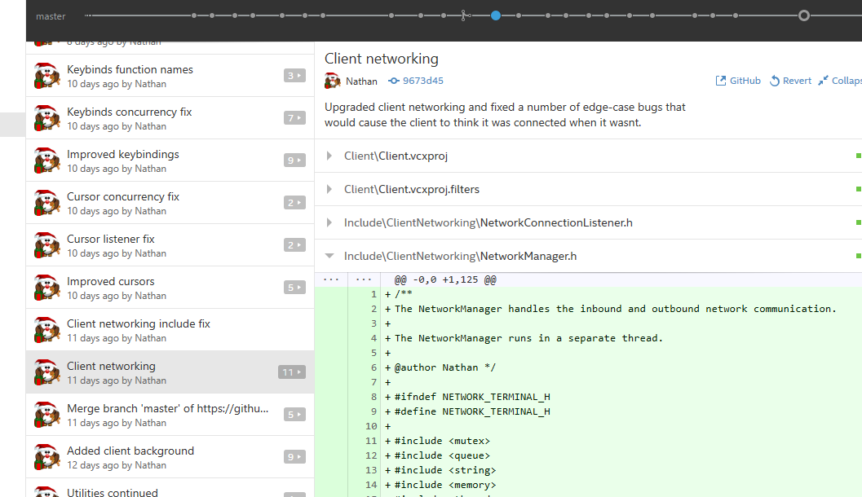

*A GitHub log extract*

Another failure that stood out amongst the projects plan was the lack of tolerance for delays or design failure. As discussed further in the technical design and development section, it was a common occurrence throughout the projects lifecycle that the produced design documentation did not cover all of the ground that it needed to. In many cases, this resulted in lengthy periods of no tangible progress whilst the design of the current and future systems was revisited in an attempt to prevent future setbacks. Unfortunately, each time that the design needed to be reworked, no progress would be made on the final product itself, meaning that the project would fall significantly behind schedule. Ideally, a document should have been produced at the beginning of the development cycle that outlined the importance of each component with regards to the completed product such that delays could be made up for by cutting less important features.

Before concluding the review of the project management, attention should be brought to one last success in the management methodologies and that is the functional requirements specification produced as part of the requirements documentation. Even though the document was written near the very beginning of the projects development period, it remained accurate and largely unedited for the entire project duration. The document was consistently used to evaluate whether current programming efforts were being used to move the project in the right direction, as well as providing a definitive list of features that would label each component as finished or unfinished. The contents of the final functional requirements specification document can be reviewed as appendix [12.2.3].

6.0 – Gameplay Design & Development

## 6.1 – The purpose of gameplay design

The purpose of gameplay design and development is to create a series of documents that can be utilised from both a technical and artistic perspective to assist in the production of the project. In a technical sense, the documents are often used to generate technical design documents based off of the perceived requirements of the gameplay mechanics. For example, if a gameplay document describes the need to be able to launch an attack in a direction of the players choosing, then it is easy to identify the requirements of both creating visual effects for attacks and for selecting a direction in which to attack.

There is no concrete way in which gameplay design documents should be produced – although most of them tend to take on some variation of a document know as a GDD or “living” document. This is the document that is written by gameplay designers and usually comes in two parts: the overview and the contents.

The overview document contains the information that would typically be used to pitch a game to investors, and contains information such as the expected age rating, story overview and gameplay style.

The content document contains information describing all of the gameplay mechanics in exceptional detail. This document is typically handed around between the game development team as a central reference point to ensure the project development stays focused and on track.

Both of these documents have been produced as part of this project [12.3.1, 12.3.2] and whilst the need to pitch the game to an investor was not present – the need to refer to a central information source very much was.

## 6.2 – Design considerations

Designing an MORPG is never a simple process and requires the interweaving of a vast number of gameplay mechanics with a series of social systems all with respect to the computational power of current generation hardware.

One of the biggest considerations made throughout the entire gameplay design process was the need to prevent server overload in any one particular location. Whilst the game is intended to emphasize the ability to play with other players and to interact with other creatures and world objects, encouraging a large collection of players to do so in one location at one time could cause server instability. As such, the layout of the game world has been designed in a way that splits up the world in to 3 evenly distributed zones in the hope that players will spread out relatively evenly. Additionally, a number of zones called “instances” or “dungeons” have been created that are temporary zones designed to accommodate a small group of players for a few hours before they are returned to the main game world. To take this even further, other parts of the content have been deliberately spread out across the individual zones to reduce the amount of updates that need to be broadcast to each player on every logical update.

Another big consideration to make was the effect of having multiple players being able to interact with each mechanic at any given time. The effects of this varied in both a technical and gameplay perspective, with things such as multiplayer combat taking a greater toll on the technical requirements whilst non-player character (NPC) AI had a greater effect on the gameplay. To further demonstrate the issues that could arise in this regard, consider the impact of a player causing an NPC to follow them to a remote location and then leaving the game world. Should the NPC remain in that position and potentially disrupt gameplay for others who then cannot find it, or should the NPC return to its original position and continue as normal. Along similar lines is the consideration of the effect on gameplay difficulty of having multiple players engage in combat with the same target all at once. Should the target become more resilient, or should bringing a larger number of players to a battle just be a no-complications advantage. As this game focuses its more challenging content in to dungeons, the latter was the desired option.

Creating a sense of achievement was also considered during the design phase of the gameplay mechanics and was found to be most easily constructed through the use of skill trees and character levels. The use of character levelling has been around since the dawn of RPG games, both computerized and pen and paper, so it would seem like an odd decision to have not included them in this project. The use of experience and levelling systems also made for a very easy way to tell players apart in terms of strength and versatility, as well as providing a means of conveying a player’s relative progress to them in a non-intrusive way. Levelling also had the advantage of being a simple means of dividing up content access in to tiers based on the current level of either the player or a skill the player possesses. Even further to the benefit of the implementation of a levelling system was that the internal representation was extremely easy to design and produce as the system depends almost exclusively on a linear counter and query-able level value.

The final consideration that was made was the overall theme that would be used throughout the game. When it comes to the production of MORPGs, there are two main themes that can be used with a reliable degree of success: futuristic with technology and medieval with magic. Whilst there are other themes available, many of them emplace un-fun restrictions or expectations on the game that may negatively affect user experience (E.G: a current day setting would make magic less believable). The decision was made to go with a medieval theme as this was the most tried-and-tested of two whilst still presenting plenty of opportunity for creativity in regards to visual, audio and mechanical direction.

## 6.3 – Design analysis

Overall, the gameplay design documentation produced for the project met a satisfactory standard and was referenced multiple times throughout various stages of development to help make important decisions.

The content component of the GDD in particular stood out as a useful documentation device as it provided a foundation for the beginnings of the technical documentation that will be described in the next section. In particular, components of the GDD were extracted and converted through various stages of planning in to ‘systems that are required to make this work’ and then finally in to entries in the functional requirements specification [12.2.3] and/or the UML architecture diagrams in appendices [12.4.1, 12.4.2]. Specific examples include: the creation of the database component on the server side for storing the skill levels of the user, the physics system for knock-back abilities that require simple force-based physics and the user interface system for supporting the various UI interactions specified in the interfaces section of the GDD.

Improving on the design documentation could likely have been done if the project had come closer to implementing the majority of the existing feature set, however the missing parts of the document were largely unclear and would remain so until much further along in the development cycle. One section that did stand out as being missing from the original GDD was information regarding the artificial intelligence controls – which could easily have been used to extend the technical requirements of the following technical design documentation. The AI component was successfully appended to the projects technical design documents further down the development path, although it certainly would have been better to have caught this issue earlier.

7.0 – Technical Design & Development

## 7.1 – The purpose of technical design

The purpose of producing a series of technical design documents for this project was to help guide the development process from start to finish with as few obstacles as possible. One of the ways that the documents help to do this is by breaking down the overall project in to a selection of smaller tasks or modules that can be completed one at a time. This in turn allows the small tasks to be plotted against some form of time graph during the project management stage to allow for easy tracking of progress throughout development.

The documents are also used to assist in the detection and resolution of design flaws at the earliest stage possible. It is highly unlikely that every technical flaw that will surface throughout the projects development will do so during the design phase, and so the produced designs should be constructed in such a way that the impact of surprise errors is minimised at discovery time.

Technical documents have also been used to outline particular rules that have been followed to improve the extendibility and maintainability of code as a whole. These documents are stricter in terms of what can be changed post-design phase and are typically used to reflect the stylistic preferences of the project. The following section covers exactly which types of documents these are in greater detail.

## 7.2 – Design documents

The technical design documentation was split up in to two main components: the style guide and the architectural specifications.

The style guide that was produced contained information such as: The method by which code will be commented and converted in to HTML code documentation, the C++ practices that have been disallowed and/or limited and the general style guide for writing header and C++ files. The guide was created as a simple word document and was referenced multiple times throughout development to ensure that the project was adhering to a consistent style. Overall, this helps contribute to a more readable and thus maintainable code-base, particularly with respect to components that are developed early in the project and then set aside for many weeks at a time.

The architectural specifications side of the documentation took much longer to produce and was delivered in the form of UML documentation and program flow charts. As the project was divided in to two components: the client and the server, two UML diagrams were produced in total separation from one another. This was primarily done to reduce visual clutter, but also helped to clarify which parts were relevant to which side of the project. Over the course of development, the UML was constantly referenced in order to draw links between tasks, gain a base understanding of how each task should be performed and to help resolve errors such as circular inclusion and bad encapsulation. From the very start of the project, it was expected that the UML would undergo several re-evaluations, with even the final diagrams not fully reflecting the perfect solution to each and every problem.

The flow charts were produced further down the projects development lifecycle and were utilised as an implementation guide rather than an architectural guide. Whereas the UML was largely used to design the classes that would house the implementations, the flow charts were used to define the order and times at which control would flow amongst classes. The charts proved to be particularly helpful towards the later stages of the project as they were referenced to determine the flow of communication between the client and server programs.

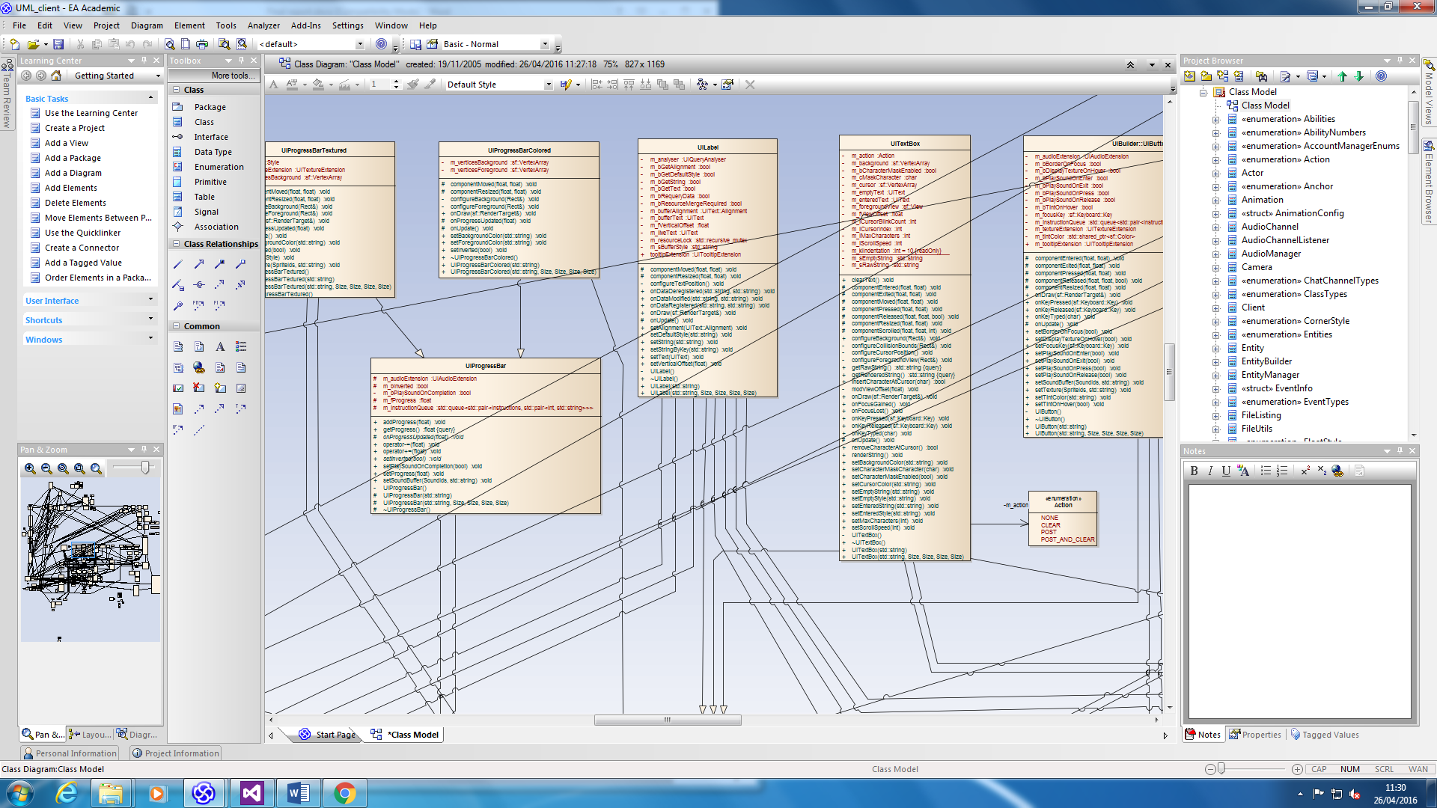

*UML extract*

## 7.3 – Design considerations

When designing the technical specification for the MORPG, a number of considerations needed to be made with respect to the scope and properties of the project as a whole.

The first and most obvious consideration that was made was the fact that the project would be split in to two completely independent programs that would be capable of running with and without each other’s existence. This meant that throughout the design phase, each component that needed to be created had to be specified as client, server or both in order to fully define the importance and requirements of the component. For the most part this resulted in the shared components such as the utilities and networking systems receiving extra scrutiny in terms of debugging and documentation. Additionally, each program needed to be developed in a way that allowed the activation of functions that would only typically occur as the result of communication between the client and server. This additional requirement was primarily laid out to ensure the simplicity of testing and debugging.

The second consideration that was made was the importance of developing each component as a standalone module. Examples of such modules include: The rendering module on the client side, the account management module on the server side and the audio module on the client side once again. Developing these modules/components in this way was done to improve the maintainability and extendibility of the program by reducing inter-module dependency through correct object orientation and encapsulation. This also helped to reduce the likelihood of bugs by limiting interaction between components to input-filtering and concurrency resolving interfaces.

Concurrency was another consideration made during the design phase as it would allow for a significant boost to system performance if it was implemented successfully. In particular, the server was most likely to benefit from concurrency as large sections of it would be capable of operating entirely independently of each other, thus reducing the potential for contention amongst threaded operations. The client side also stood to benefit from concurrency, although significantly less so than that of the server side.

The need for an expansive user interface (UI) was also high on the list of considerations when designing the technical specification for the client program. User interfaces are notoriously difficult to get right due to the exceptionally large feature set and the way that modern UI’s are expected to behave. Implementing each and every feature of such a system is an entire project in of itself, and so the specification for this project has been limited to only include the necessary components. In many cases, this allowed for corners to be cut in the development cycle without too much of a knock-on effect on the modules extendibility.

Network security also acquired my attention during the design phase as the importance of defending against a number of the issues listed in the literature review could not be entirely ignored. Whilst some of the issues do go beyond the scope of the project, others such as limiting game master tools, preventing cheating and server authorisation do not. In this respect, effort was made throughout the client and server networking systems to provide a means of verifying the sender and receiver of each communications exchange.

The final consideration that was made in the technical design documentation production stage was the effect of having either a server side only or a client and server synchronised collision detection and resolution system. Whilst using a server side only approach would result in a significantly easier to develop system, the overall user experience was likely to be negatively affected by the delays and inconsistencies associated with communication over a network. Using a client and server synchronised version however would be much harder to develop and would likely introduce inaccuracies to the visual output unless the synchronisation methods were exceptionally well made.

## 7.4 – Design analysis

The stylistic design documents proved to be a very beneficial addition to the project overall and have contributed greatly to maintaining a standardized and consistent approach to each technical challenge. The documents did not need to be updated a single time and instead provided all of the information required to code from start to finish without interruption.

One example of the style guide that was exceptionally useful was the standard class definition template. This template was used across hundreds of classes to great success and ensured that whenever a class was revisited it was easy to find the relevant parts and their explanations.

The architectural documentation was not quite as successful and instead needed to be modified multiple times throughout development. Notably, the first version of the UML diagrams bare almost no resemblance to the current ones in terms of detail, complexity and structure as the design was updated to match evolving requirements.

One such update that occurred in the second phase of development was the addition of the chat service to the server side UML – a component that had been previously bundled in to the realm management component. This separation of systems further assisted in the maintainability of the program by reducing interlocking between classes and limiting interaction interfaces even further.

Updating the UML constantly in this way did not have too much of an impact on the established parts of the project overall, although did reveal that the complexity of the systems far exceeded that of the original expectation. Whilst it would be possible to minimise the time taken to produce the newly designed systems, it would result in a codebase that would be not too far short of impossible to extend: a very dangerous trait for a game that evolves as frequently as MORPGs do.

8.0 – Testing

## 8.1 – The purpose of testing

Testing is an important stage of the development cycle as it presents an opportunity for a developer to ensure the success and stability of their work in both a qualitative and quantitative manner. The reason that testing is so important with respect to MORPGs is that these types of games rely heavily on their ability to draw in and immerse players in a fantasy gaming world. Should that immersion be disrupted due to a software failure – be it client or server – the user experience would be negatively impacted relative to the seriousness of the failure. To make matters worse, the nature of a MORPG means that a server-side fault does not impact just one player – but potentially hundreds or thousands depending on both the popularity of the game and the particular server that experienced the error.

Whilst this particular project does not serve numbers close to that of an already established MORPG, it does still require the same level of thoroughness with respect to each component of the software in order to guarantee reliability. Producing a test plan that would be capable of providing this guarantee was not a simple task and required extensive use of four key types of testing: black box, white box, unit and user.

## 8.2 – Testing methodologies

The usefulness of each type of testing varied from component to component, with qualitative testing (user experience) being more important on the client side software and quantitative (black, white, unit) being more important on the server side.

### 8.2.1 Black box testing

Blacking box testing was used in the early stages of the testing process to determine the success of functionality on both the client and server sides and also to highlight areas that needed a more focused testing approach. This form of testing was quick to reveal whether a component of either the client or server was functioning as intended, and was advantageous to the development cycle in the sense that the tests were quick to write and execute. Additionally, as black box testing focuses more on the success of functionality rather than the means by which that functionality is performed, it was the ideal choice for testing the client-side of the software as this is what matters most to the end user.

The black box tests themselves were simply a matter of executing functionality (E.G: Creating an account) and recording the differences between the expected output and the actual output.

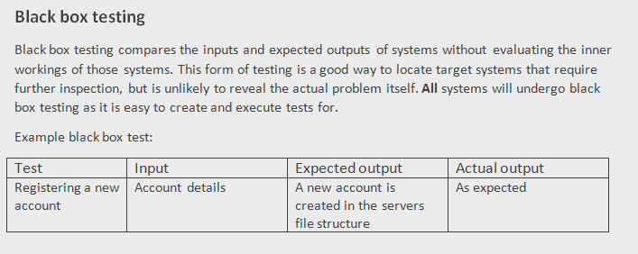

*Black box test plan as described in the test plan*

|  |  |  |  |
| --- | --- | --- | --- |
| **Test** | **Input** | **Expected output** | **Actual output** |
| Audio | | | |
| Playing a track | The name of the track to play | The track plays |  |
| Stopping a track | A track that is already playing | The track fades out over the specified period of time |  |
| Queueing a track | The name of the track | The track is appended to the back of the queue and plays when it is its turn |  |

*Black box test grid extract*

### 8.2.2 White box testing

White box testing allows for a more precise look in to the internal workings of the systems it is executed upon and thus would provide much better feedback when used on systems that cannot afford to be executing incorrectly. Such systems reside largely on the server side of the project, and include components such as the database, account management and network management. The reason that these components should receive black and white box testing is that even if the functionality seems to be working, moving corrupted or partial data around a system is likely to cause errors to surface in other places that could result in a system failure.

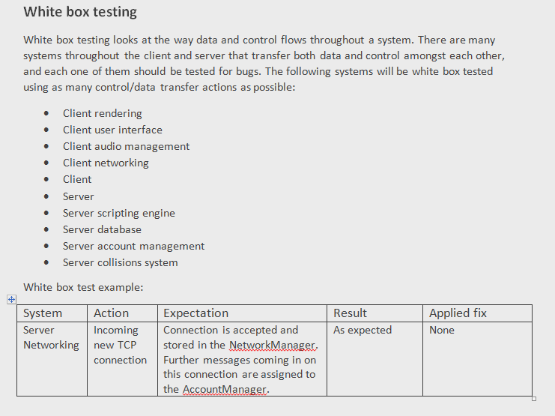

*White box test plan as described in the test plan*

|  |  |  |  |
| --- | --- | --- | --- |
| **Test** | **Input** | **Expectation** | **Result** |
| Audio | | | |
| Playing a track | The name of the track to play | The track is opened if it exists and configured according to the saved specification. If another track is playing, it is set to fade out. The new track fades in if specified |  |
| Stopping a track | A track that is already playing | The track is set to fade out or is stopped immediately. The current music becomes a nullptr |  |
| Queueing a track | The name of the track | The desired music is appended to the back of the music queue object with its settings stored as a MusicQueueInfo object |  |

*White box test grid extract*

### 8.2.3 Unit testing

Unit testing is the most thorough form of testing used in this project and has been utilised in areas that can be considered critical sections or sections most likely to contain bugs. Examples of such sections include the networking components of both the client and the server and the permanent storage interaction that occurs on the database. The reason these components stand out is because of their inability to ‘recover’ from corrupted state with ease and the consequences of misplacing data that represents a user’s playtime.

Unfortunately, unit testing is by far the most time consuming type of testing that can be performed on a piece of software, as each individual function on each class must be tested against a series of valid and invalid inputs (boundary testing). Where time is a limited resource, it is often considered a good idea to use other forms of testing such as white and black box to highlight which components should undergo the process of unit testing.

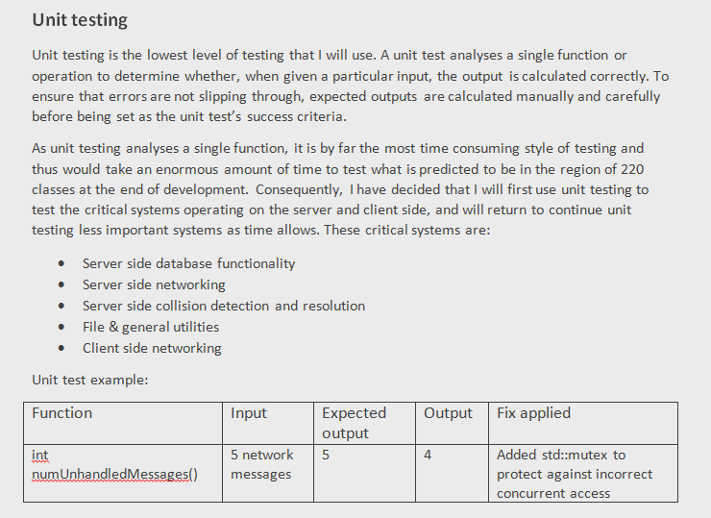

*Unit test plan as described in the test plan*

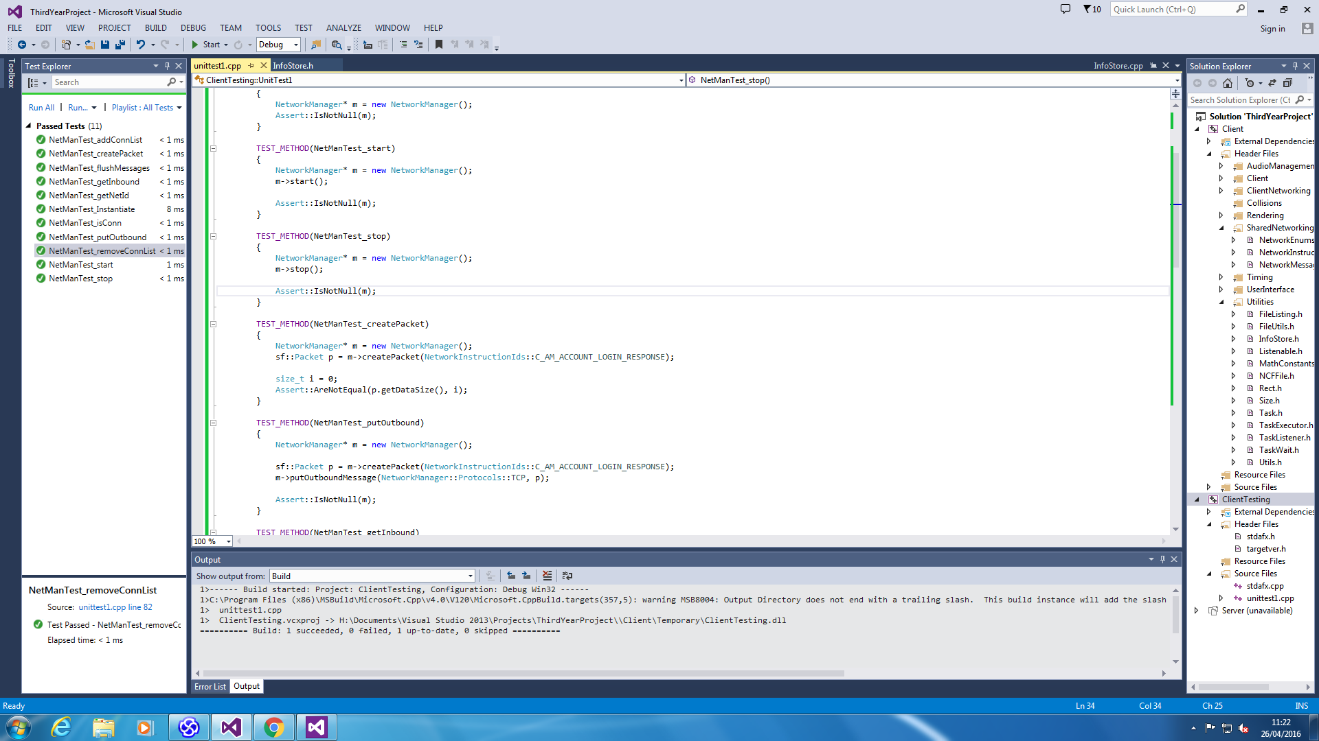

*Unit testing extract*

### 8.2.4 User experience testing

User experience (UX) testing was primarily used on the client portion of the project to determine whether a player with no previous knowledge of the game found interaction with the client intuitive and fair. To do this, the user had to be exposed to each part of the gameplay experience with the ability to provide feedback at each stage regarding their thoughts and feelings. In some cases it can be a good idea to expose a user to only a small portion of the client to retrieve much more focused feedback, however this was not a strategy that was used during this project as an all-round feel was more important than the usability of one particular component. A segment of the user experience test plan that was produced and carried out by 3 members of the public has been included below. The full document can be found in the appendices section.

UX testing was also used on the server side to help determine whether entering commands through the command console was a satisfactory experience or not. It is worth noting the expectations are vastly different here in comparison to the client side UX testing as the only ‘users’ of the server side command console should be system administrators or developers. As such, the readability and responsiveness of the commands adopt a lower priority than that of rich functionality and filtered input.

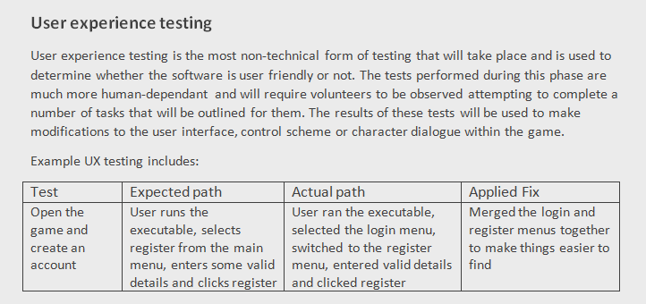

*User experience test plan as described in the test plan*

|  |  |  |  |
| --- | --- | --- | --- |
| **Test** | **Expected actions** | **Actions taken** | **User comments** |
| Registering a new account | The user will select the register option from the main menu, will enter their desired details and will press the register button |  |  |
| Logging in to an existing account | The user will select the login option from the main menu, will enter their login information and will press the login button |  |  |
| Muting the music | The user will select the options option from the main menu and press the mute music button |  |  |
| Zooming the camera | The user will scroll the mouse wheel |  |  |
| Selecting a menu | The user will select a menu using the mouse and a left click on the relevant button |  |  |
| Closing the game | The user will select the quit button or the window cross |  |  |
| Skipping the splash screen | The user will press the enter or escape key to skip the splash screen |  |  |

*User experience test grid extract*

## 8.3 – Test result analysis

The testing process is a difficult one to get right as it requires finding the right balance between executing a thorough testing plan and wasting an enormous amount of time looking for errors that simply don’t exist.

The testing took place in two key phases: the higher level black box and user experience testing and the lower level white box and unit testing. The process was divided in this way to save time on less important systems such as the audio manger under the conditions that they satisfy all of the higher level testing criteria without any noticeable errors.

Other systems such as the networking components of both the client and server cannot afford to skip the lower level testing however as they rely heavily on their internal operations behaving correctly.

The test results themselves proved to be a useful asset in the finishing stages of the product. As seen in a number of the testing grids found in the appendices, a few bugs and user suggestions surfaced that would be fairly easy to resolve in a small amount of time.

One such bug that was revealed via black box testing was a very minor bug where test code had been left in in place of the actual code. An issue such as this one, whilst likely only to occur on projects of a small scale like this one is a great example of how testing can reveal and resolve bugs in very short spaces of time.

The user experience testing was equally as successful but less statistical in nature. Users were observed completing a number of tasks that had been laid out in front of them and were asked if they had any comments on the completion of that task. Whilst most often the user had no comments to give, occasionally a suggestion would be put forward that could be compared with other user’s comments to determine whether a change should be made to benefit the overall user experience.

Whilst each form of testing was useful, the white box testing had to be the most productive of them all for this project. As the systems are fairly small and developed by a single person, maintaining the context of operation in memory was easy to do and made writing and executing white box tests almost as quick as black box tests. The tests also revealed a number of issues that were either rare or hardly noticeable and could have easily slipped under the view of the user experience or black box testing. Of course, performing unit tests on the class would have revealed the same issue, but the difference in time between writing unit and white box tests is not something to disregard.

Overall the testing plan helped to produce a series of results that were successfully used to make a number of small but key bug fixes and changes to the programs to improve the user and administrator experiences. The only practical improvement that could have been made to the testing process is to simply do more.

9.0 – Project evaluation

# 9.1 Project management evaluation

The project management side of the project was by far the most disappointing component as it failed to deliver on a number of key concepts that could have been a significant boost to productivity if they had been done correctly.

The most notable issue that surfaced approximately 3 months in to the project was the poor assignment of tasks to the Gantt chart produced as part of the management documentation. The chart contained a set of tasks that had been assigned a certain number of weeks with which to be completed within with effectively no flexibility to account for delays should they occur. This proved to be highly problematic as attempting to follow the chart was not only troublesome in terms of keeping up but also in terms of the order in which tasks should be completed. The order had been naïvely constructed based of a loose understanding of what it would take to create the final product. As mentioned in the technical evaluation section below, this understanding changed throughout the development cycle in ways that the project management documentation could not adapt to. The reason that this poor assignment occurred could be viewed from two perspectives. The first perspective would be that the understanding of the project requirements simply was not there at the time of planning. This is an experience issue that could be resolved with further research, consultations with those who have experience in the area and further trial and error development time. The second perspective was that the use of a Gantt chart lead the project down a route that was not flexible enough for the type of project being undertaken. If a different planning method such as a burndown chart with accompanying priority list had been used instead, the development rate of the project could have been affected a great deal less.

One thing that did stand out as a positive experience from the project management was the use of the source code management software GitHub. The software was used effectively throughout the duration of the project to ensure both the safety and correctness of the master copy of the two programs at all possible times. Fortunately, there was never a situation where GitHub was required to roll back the programs to a previous version or where the project was lost and needed to be reacquired from the master copy. It is very reassuring to know however that if this had happened at any point, the situation was covered and could be resolved with relatively minimal losses.

Unfortunately this component of the project cannot be considered a success due to the impact of the bad task planning and thus encouragement is given to anyone engaging in a similar project to seek the advice of a veteran in the MORPG development market.

# 9.2 Gameplay design evaluation

The gameplay design is a difficult portion of the project to evaluate as a number of the features that were outlined in the design documentation did not make it in to the final product due to time constraints. Of those that did make the final cut, most adhered to the desired GDD specifications with little need to modify the document as time went along. It should be stated however, that the very nature of being able to modify the document with a great deal of flexibility was a positive influence on the development of the project. In particular, the freedom with which features could be added to or updated within the GDD made for an uninhibited development environment that still ensured all the necessary data could be found within a single location. Whilst this may raise the concern that the document could specify a change to a feature that has already been developed with no intention of being revisited, this problem could easily be avoided by using a file-modification tracking procedure. Luckily this was not required within this project especially when the game designer and technical designer are the same person. In situations where they are not the same person, this procedure should most likely be implemented to avoid communication failures.

Attention could now be drawn to one particular success from within the GDD, and that is the level to which the gameplay design considerations have been acknowledged through the desired mechanics of the game. The GDD very cleverly defines the zones that the players will play within: which have in turn been very successfully divided up across player levels and total world space. Furthermore, content has been spread out amongst the space within those zones as requested by the server load consideration. The specifics of this can be seen by reviewing the zone maps and accompanying key tables in the zones section of the GDD. Other noteworthy components include the inclusion of skills to satisfy the sense of achievement and the medieval magic theme expanded upon via the equipment and story sections.

A limitation that was observed from the game design document was the lack of order of importance amongst features. The document assumes from the get-go that each and every feature or theme that has been documented will find its way in to the final product. Unfortunately, this was far from true once the deadline had approached and the GDD simply did not provide a means of reducing the end-game expectations to still produce a well-rounded game. Of course, an argument can be made that this extends beyond the responsibilities of the GDD and in to project management, although an optimal solution could be to document feature importance in both. This could be extended on even further to provide a series of versions of the game that contain ‘bundles’ of features that work well together to produce their own individual games. These bundles could then be put in order such that developing the game occurs in incremental stages whilst still remaining well-rounded. It is believed that should this feature have been present during the development of the project, time and focus would have been better kept.

Overall the game design could still be considered mostly a success with minor areas for improvement being readily available should the project be revisited in the future.

# 9.3 Technical design evaluation

The technical design documentation was one of the greater successes of the project and stood to be a useful asset from start till finish.

The style guide that was produced at a very early stage of the development cycle was used throughout the entirety of development to ensure the consistency of the codebase from a first and third party perspective. The styles chosen were done so to put an emphasis on readability and clarity whilst making sure the comments could be parsed and converted in to Doxygen documentation whenever necessary. The style guide overall was very successful in conveying meaning and clarity in variable names, function names and class comments, but was not without some additional complexity. Following the style guide during times of difficulty, especially with respect to redesigning the architecture of a subsystem, added an unwelcome strain on productivity as a result of the need to write comments and names in a specific way in places that may end up being removed. Luckily, this was a non-issue for the better part of the project.

The UML diagrams were also very successful in providing a useful reference point for the client and server architectures during times of programmatic difficulty. The diagrams were frequently used to reason about the context, solutions and direction of the subsystems within the programs and were created as part of a continuous process of designing and redesigning where necessary.

Early versions of the UML did not contain a great deal of information and were more focused on securing the structure of the programs and the general means of communication between the subsystems (audio to game states, accounts to realms, etc.). As the project moved forward and the needs and requirements changed, the UML would be updated to use better software and provide more accurate information. This method of iterative development was particularly successful when used in conjunction with the agile development methodology as it provided a synergy between the tasks to complete and the production of the design work to go with it. This worked well for as long as systems were developed with minimal inter-system dependencies so that they could be reworked and repurposed where needed. In some ways, this iterative method did result in slowing down development of the project by causing areas to be revisited multiple times, however that slowdown was largely offset by improved overall code quality. Furthermore, whilst the method worked well for this particular project, it would certainly cause issues in projects with more than one developer as the lack of shared context could cause misunderstanding and miscommunication.

# 9.4 Testing evaluation

The testing component of the project turned out to be more successful than first expected in regard to the quality and effect of the testing on the project as a whole. The primary testing phase, that included black box and user experience testing, was completed within the very reasonable timeframe of 2 days and provided simple and concise feedback on the areas that needed to be investigated or functionally reworked. Of course, these two types of testing are very different from one another in both purpose and objective and thus their respective results were interpreted in notably different manners.

The black box testing was the first kind of testing both performed and interpreted and was used with the intention of detecting and investigating further bugs at a functional level. The limitations of this kind of testing are well known in that it cannot be used to provide an in-depth analysis of the problem occurring with the system. Rather, the tests are merely used to highlight troublesome areas so that they can be tackled by either stepping straight in to the code or by performing white box testing to narrow down the problem. In a project of this size and scale, the former solution revealed itself to be the easier method of tackling black box errors as the internal systems were often not complex enough on their own to make the bug fixing process difficult.

Considerations were made for the fact that user experience testing is very volatile in terms of results, as users can be subjected to being overly critical or too lenient depending on mood and a variety of other human factors. During the results analysis phase, this was accounted for by attempting to highlight patterns in user responses that were then used to determine whether a change should be made. This helped to filter out unusual responses that if acknowledged in full could result in a change being made that would negatively affect the main user bases gameplay experience. The outlying responses were not ignored entirely though, as such responses could be used to identify issues that the majority of players simply did not notice. Fortunately this was not the case for this project and no extreme comments or gameplay side effects were found during testing. Generally speaking, the best way to engage in user experience testing is to use a very focused group of individuals that have been selected based on some criteria (age, employment status, gender, etc) or to just use an incredibly large sample size of random players (greater than 10000).

The second phase of testing used a much more technical (and time consuming) approach in the form of white box and unit testing and was used in places of technical complexity that were expected to contain subtle problems. The results harvested from these tests were more technical than their earlier English counterparts and as such had to be interpreted by someone who already understood the system being tested.

The white box testing stage had a debatable level of success in the areas that it was used because even though the tests were completed thoroughly across a number of subsystems, they did not manage to reveal a significant number of bugs. The process of performing these tests proved to be fairly slow as the primary method of doing them involved stepping through the code one function at a time using a debugger. The good thing about testing in this way however is that the results were extremely useful for detecting issues for as long the person performing the tests was acknowledging the context of the work taking place.

The unit testing stage was a largely underrepresented portion of the project as it was only used to test a few specific “high-threat” classes. More than any other reason this was due to the time constraints associated with the creation of good unit tests. Interestingly, of the unit tests that were performed, absolutely no bugs were detected in the target code which presents the possibility that the expectation of bugs lead to a higher level of scrutiny during the programming stage. Fortunately, the write-once run-many nature of unit testing now means that any future modifications to the areas that have been unit tested can be done with a high degree of bug-free confidence.

The testing phase overall was completed with a reasonable degree of success but could definitely benefit from expanded coverage in the future. The number of bugs and issues detected and resolved as a result of the testing was acceptable for the size of the project but will always be considered with the knowledge that tests are intended to prove that bugs could not be found – not that they don’t exist.

# 9.5 Product evaluation

The final section to review for the evaluation is the overall product that has been created. There are a very large number of points that could be discussed in relation to the two programs, although some had a much greater impact, both positive and negative, on the project as a whole.

One of the more technical points is the use of concurrency in both the client and server programs to improve efficiency. More often than not, multithreading is a trap that newer developers can fall in to when chasing an incredibly high performance system and end up with equal or worse performance and some very messy code. On the client side user interface – this is exactly what has happened. At the earliest stage of development, the decision was made to process the user interface and the asset loading in separate threads such that the interface would never become unresponsive and the user experience would be improved. Whilst the benefits of this act are very much in action – the technical debt and extra complexity stemming from the interface operating in another thread has caused constant issues throughout the project. Fortunately, this is the only threaded operation that has backfired so far, and all other client and server multithreading has resulted in high performance program execution. Examples of beneficial concurrency can be seen on the client and server side in both network management centres.

Another technical point worth mentioning was the sheer scale of the client side user interface. Whilst it was always intended to develop a highly interactive, highly functional user interface containing the majority of functionality found in any modern day UI, the sheer number of classes and considerations to make throughout the entire process was extremely challenging. The final result satisfies approximately 90% of the cases that the project set out to target and has provided a reasonably simple means of extending the interface to support more component types. The ability to use a data driven approach to interface loading has also been very helpful, especially when it comes to the development of the game world data.

Further to the technical side of things, the frame-work on which the client and server have been built is very robust and is very unlikely to crash in standard operational situations. Extra care was taken throughout to ensure correct memory management and an easily extendable architecture through the use of GameWorld and Zone based functionality.

On the other side of the argument are the visual and gameplay portions of the project. Unfortunately, many parts of these categories did not make the final cut in the product as a push was made to round off the edges of the game and secure a final working product. This was largely due to a gross misunderstanding of the sheer amount of work it takes to produce a fully functional MORPG with a reasonable degree of gameplay. Even with the use of additional supporting technologies, the complications of linking together so many subsystems to create a networked persistent virtual world are far beyond the scope any reasonable one man project. The client and server as is provide just enough gameplay to demonstrate that the internal systems are online and functioning, but the gameplay itself can be considered lacking.

10.0 – Conclusions

Now that the project has come to an end, a few conclusions can be drawn in reference to the overall project and the general subject area itself.

One such conclusion that could be drawn would be the importance of respecting the additional workload that comes with creating a networked game world. Where other games may be able to simply create a physics system on the target computer, a networked game needs to accommodate for many other factors such as network synchronisation, cheat protection and network load. Depending on the quality of the network synchronised systems, the workload for any given component could see 2 or even 3 times as much time being sunk in to it.

Another conclusion that stood out throughout the project was the difficulty of implementing scalable data persistence in to a game world and its supporting systems. Previous game development projects that have had persistent data have merely been a case of loading text files and parsing them on a system-by-system basis. An MORPG is very different as it demands an exceptional amount of flexibility in terms of file loading and saving: especially with regards to account and content creation. Prior to the implementation of data persistence amongst network communications, the overall server responsibility was much lower and thus easier to develop.

The importance of usability also turned out to be a common theme for the duration of the project and was highlighted in both the development time dedicated to an interactive client and the responsiveness of the server command terminal. At various points it was reiterated that both sides of the project needed to be not just highly functional but also highly controllable – especially as MORPGs are renowned for their data intensive interfaces.

The final conclusion to mention in this report is the potential for extension to the project based off of what is now known and what has been produced. Extensions to the gameplay and systems themselves range greatly from additional zones to performance improvements and from extra gameplay mechanics to extended social systems. It is important to consider that each new addition to the project adds another strain on the existing system that has known flaws that will eventually catch up the continuing developer. If the project was to be continued, it is recommended that portions of the server be re-written to suit a more scalable architecture that could potentially allow the server to run across multiple processes or even multiple physical servers.

Unfortunately, to take this particular project much further than the areas suggested above would soon result in approaching the limitations of the technology that was chosen to support the networking, databases and rendering of the two programs. SFML provides a great deal of convenience by hiding much of the complexity associated with handling each subsystem; however it also hides much of the potential for significant performance improvements. Without the additional performance gains of a custom implementation in these respects, the distance that this project can be pushed before becoming impossibly troublesome to work with is limited. It is therefore suggested that taking this project forward is done by acknowledging the successes and failures of this implementation and then using them to assist in the development of a brand new version using more powerful industry-standard technology such as MySQL, Lua, GLFW and OpenGL shaders.

# 11.0 References

Anders Tychsen, M. H. T. B. M. K., 2005. The Game Master. *Proceedings of the second Australasian conference on Interactive entertainment,* pp. 219 - 221.

ArenaNet, 2015. *Homepage.* [Online]   
Available at: https://www.guildwars2.com/en/the-game/?

ArenaNet, 2016. *Rules of Conduct.* [Online]   
Available at: https://www.guildwars2.com/en/legal/guild-wars-2-rules-of-conduct/

ArenaNet, 2016. *User Agreement.* [Online]   
Available at: https://www.guildwars2.com/en/legal/guild-wars-2-user-agreement/

Bernier, Y. W., 2001. *Latency Compensating Methods in Client/Server In-Game Protocol Design and Optimization.* [Online]   
Available at: https://developer.valvesoftware.com/wiki/Latency_Compensating_Methods_in_Client/Server_In-game_Protocol_Design_and_Optimization#Lag_Compensation

Blizzard Entertainment, 2016. *WoW ToU.* [Online]   
Available at: http://us.blizzard.com/en-us/company/legal/wow_tou.html

Braithwaite, A., 2015. The Evolution of "Multiplayer" in Word of Warcraft. *Games and Culture,* pp. 7-8.

Burnell, L., 2016. *Where is the MMO genre heading.* [Online]   
Available at: http://www.tentonhammer.com/columns/where-is-the-mmo-genre-heading

Damien, V., 2015. *Glossary of Terms.* [Online]   
Available at: http://www.icy-veins.com/heroes/glossary-of-terms

Funkhouser, T. A., 1996. Network topologies for scalable multi-user virtual environments. *Virtual Reality Annual International Symposium,* pp. 222-228.

HackMag, 2016. *Deceiving Blizzard Warden.* [Online]   
Available at: https://hackmag.com/uncategorized/deceiving-blizzard-warden/

Hughes, M., n.d. *Video Game Glossary.* [Online]   
Available at: http://www.factmonster.com/science/computers/video-game-glossary.html#i

Jagex, 2016. *Terms.* [Online]   
Available at: http://www.jagex.com/terms/terms.ws

Jens Muller, S. G., 2004. A Scalable Architecture for Multiplayer Computer Games. *GI Jahrestagung,* pp. 154 - 158.

Leigh Achterbosch, R. P. G. S., 2007. Massively multiplayer online role-playing games: the past, present, and future. *Computers in Entertainment,* pp. 19-21.

Marios Assiotis, V. T., 2006. A Distributed Architecture for MMORPG. *The 5th Workshop on Network & System Support for Games,* p. 4.

Maynard-Koran, P., 2016. *Fixing The Internet For Real Time Applications.* [Online]   
Available at: https://engineering.riotgames.com/news/fixing-internet-real-time-applications-part-ii

McGraw, G., 2005. *When Does Security Cross The Line?.* [Online]   
Available at: https://www.cigital.com/papers/download/0512sec.wow.pdf

Mjamias, 2013. *MMOs 2012-2014 Analysis.* [Online]   
Available at: http://www.killerguides.net/blog/mmorpg/mmos-2012-2014-analysis

NCSoft, 2016. *Aion User Agreement.* [Online]   
Available at: http://us.ncsoft.com/en/legal/user-agreements/aion-user-agreement.php

Nicolas Ducheneaut, N. Y. E. N. R. J. M., 2006. Building an MMO with Mass Appeal. *Games and Culture Vol 1 Num 4,* pp. 12-13.

Olof Hagsand, R. L. M. S., 1997. Using Spatial Techniques to Decrease Message Passing in a Distributed VE System. *Proceedings of the 2nd Symposium on VRML,* pp. 7-15.

Pfeifer, S. A., 2007. Real-time Multiplayer Gaming: Keeping Everyone on the Same Page.

Riot Games, 2016. *Homepage.* [Online]   
Available at: http://euw.leagueoflegends.com/

Sherinian, K. V., 2014. United States of America, Patent No. 20140129434.

Tobias Fritsch, H. R. J. S., 2005. The Effect of Latency and Network Limitations on MMORPGS. *NetGames '05 Proceedings of 4th ACM SIGCOMM workshop on Network and system support for games,* pp. 3-6.

Wang Jianmin, Z. Z. P. T. L. J., 2010. Optimization Technique in a Commercial MMORPG on Mobile Phone. *Entertainment for Education. Digital Techniques and Systems,* pp. 34-45.

Wikipedia, n.d. *Multiplayer Online Battle Arena.* [Online]   
Available at: https://en.wikipedia.org/wiki/Multiplayer_online_battle_arena

WoWPedia, n.d. *Gates of Ahn'Qiraj.* [Online]   
Available at: http://wow.gamepedia.com/Gates_of_Ahn%27Qiraj

Yang-Wai Chow, R. P. M. R., 2005. A Message Update Model for a Large-scale Multi-user Networked Virtual Environment System. *Multimedia Cyberspace Journal.*

Yee, N., 2004. *Hours of Play Per Week.* [Online]   
Available at: http://www.nickyee.com/daedalus/archives/000758.php

Yee, N., n.d. *Gateway Demographics.* [Online]   
Available at: http://www.nickyee.com/daedalus/gateway_demographics.html

12.0 – Appendices

### 12.1 Testing appendices

**12.1.1 Black box tests (full)**

Client

|  |  |  |  |
| --- | --- | --- | --- |
| **Test** | **Input** | **Expected output** | **Actual output** |
| Audio | | | |
| Playing a track | The name of the track to play | The track plays | The track plays |
| Stopping a track | A track that is already playing | The track fades out over the specified period of time | The track faded out over the specified period of time |
| Queueing a track | The name of the track | The track is appended to the back of the queue and plays when it is its turn | The track played when it is was its turn |
| Loading a track | The name and file location | A track is loaded and may then be referenced by the assigned name | The track was loaded and could be referenced by the assigned name |
| Loading a sound effect | The name of the sound effect and the file location | The sound effect is loaded in to memory | The sound effect was loaded in to memory |
| Playing a sound effect | The name of the sound | The sound plays | The sound played |
| User interface | | | |
| Loading an interface | An interface file name | The interface is loaded in to memory | The interface was loaded in to memory |
| Unloading an interface | An interface id | The interface is unloaded | The interface was unloaded |
| Binding an interface | An interface id | The interface is bound | The interface was bound |
| Binding a keyset | A keyset | The keyset is bound | The keyset was bound |
| Binding a mouseset | A mouseset | The mouseset is bound | The mouseset was bound |
| Binding a cursor | A cursor | The cursor is bound | The wrong cursor was bound |
| Clicking a button | A button | The button temporarily displays its pressed texture | The pressed texture was temporarily displayed |
| Clicking a checkbox | A checkbox | The checkbox switches its texture between the checked and unchecked versions | The textures swapped as expected |
| Typing in a textbox | A textbox | Text appears in the text box | Text appeared slightly out of sync with the text boxes position |
| Scrolling over a button | A button | The hover texture of the button is temporarily shown | The hover texture was temporarily displayed |
| Word wrapping text | A text string greater than the size of its container | The text is wrapped around to the next line as it reaches the bounds of its container | The text was wrapped around as it reached the bounds of its container |
| Tooltips on hover | A button | A tooltip is displayed when a tooltip-enabled component is hovered over | A tooltip was displayed when the component was hovered over |
| Tooltips remain on screen | A tooltip and a button near the right edge of the screen | The tooltip moves to the left side of the mouse when there is not enough space on the right | The tooltip moved from the right to the left when there was no longer enough space on the right |
| Showing a component | An interface component | The component will become visible | The component became visible |
| Hiding a component | An interface component | The component will become invisible | The component became invisible |
| Animating a component | A component with an attached animation | The component will fade and move | The component faded and moved |
| Rendering | | | |
| Rendering an entity | An entity | The entity is rendered on screen | The entity was rendered on screen |
| Networking | | | |
| Loading a network configuration from a file | A network configuration file | The network configuration is loaded from a text file | The configuration was successfully loaded |
| Accepting TCP connections | An incoming TCP connection | The connection is established | The connection was established |
| Receiving TCP messages | An incoming TCP message containing dummy data | The message is received | The message was received |
| Receiving UDP messages | An incoming UDP message containing dummy data | The message is received | The message was received |
| Sending TCP messages | An sf::Packet with dummy data | The message is successfully sent via the pre-established TCP connection | The message was sent |
| Sending UDP messages | An sf::Packet with dummy data | The message is sent | The message was sent |

Server

|  |  |  |  |
| --- | --- | --- | --- |
| **Test** | **Input** | **Expected output** | **Actual output** |
| Account management | | | |
| Creating an account | Username and password | Account is created | Account was created |
| Deleting an account | Username and password | Account with the given username was deleted | Account with the given username was deleted |
| Modifying an account | Username, password, property to modify and new | The property on the account was modified | The property on the account was modified |
| Changing a password | Username, old password, new password | The password associated with the username is changed from the old password to the new password | The password associated with the username was changed from the old password to the new password |
| Networking | | | |
| Loading a network configuration from a file | A network configuration file | The network configuration is loaded from a text file | The configuration was successfully loaded |
| Accepting TCP connections | An incoming TCP connection | The connection is established | The connection was established |
| Receiving TCP messages | An incoming TCP message containing dummy data | The message is received | The message was received |
| Receiving UDP messages | An incoming UDP message containing dummy data | The message is received | The message was received |
| Sending TCP messages | An sf::Packet with dummy data | The message is successfully sent via the pre-established TCP connection | The message was sent |
| Sending UDP messages | An sf::Packet with dummy data | The message is sent | The message was sent |
| Database | | | |
| Loading a database | A database folder | The database is loaded in to memory | The database was loaded in to memory |
| Saving a database | A database in memory | The database is saved to the hard drive | The database was saved to the hard drive |
| Creating a table | A table | A table is created in memory and saved to the hard drive if specified | The table was created in memory and saved to the hard drive if specified |
| Deleting a table | A table name | A table with the given name will be deleted if available | A table with the given name was deleted where available |
| Adding a row to a table | A table name and row name | A row is created in memory in the table if it is available | A row in the table was created if the table and row name was available |
| Deleting a row in a table | A table name and row name | A row is deleted from the table in memory if it was available | A row in the table was deleted if it was available |
| Mounting tables | A number of database folders | The databases are mounted when the database is initialised | The databases were mounted |
| Realm Management | | | |
| Starting a realm | A realm name | The realm is started | The realm was started |
| Stopping a realm | A realm name | The realm is stopped | The realm was stopped |
| Locking a realm | A realm name | The realm is locked | The realm was locked |
| Unlocking a realm | A realm name | The realm is unlocked | The realm was unlocked |
| Creating a character | A username, character name and character properties | The character is created | The character was not successfully created |
| Deleting a character | A username and character name | The character is deleted | The character was deleted |

**12.1.2 White box tests (full)**

Client

|  |  |  |  |
| --- | --- | --- | --- |
| **Test** | **Input** | **Expectation** | **Result** |
| Audio | | | |
| Playing a track | The name of the track to play | The track is opened if it exists and configured according to the saved specification. If another track is playing, it is set to fade out. The new track fades in if specified | Crashes on the second call. Nullptrs were not being nulled correctly on fade |
| Stopping a track | A track that is already playing | The track is set to fade out or is stopped immediately. The current music becomes a nullptr | As expected |
| Queueing a track | The name of the track | The desired music is appended to the back of the music queue object with its settings stored as a MusicQueueInfo object | As expected |
| Loading a track | The name and file location | The track is loaded in to memory stored as a mapping between two strings in a vector | As expected |
| Loading a sound effect | The name of the sound effect and the file location | The sound effect is loaded in to memory and stored in an sf::SoundBuffer on the heap. The sound counter is incremented | As expected |
| Playing a sound effect | The name of the sound | The sound buffer is played if it is available via the sound node that called its play function | As expected |
| User interface | | | |
| Loading an interface | An interface file name | The interface is loaded in to memory and stored as a UI object. It is assigned a unique id by the UIManager | As expected |
| Unloading an interface | An interface id | The interface is removed from the UIManager and allows its structure to naturally collapse as shared pointers hit 0 references | As expected |
| Binding an interface | An interface id | The interface id is queried for existence. If it existed, it is bound. If an existing interface was bound, it is first unbound | As expected |
| Binding a keyset | A keyset | The keyset id is queried for existence. If it existed, it is bound. If an existing interface was bound, it is first unbound | As expected |
| Binding a mouseset | A mouseset | The mouseset id is queried for existence. If it existed, it is bound. If an existing interface was bound, it is first unbound | As expected |
| Binding a cursor | A cursor | The cursor id is queried for existence. If it existed, it is bound. If an existing interface was bound, it is first unbound | Caused a crash under rare circumstances. Needed concurrency protection elsewhere |
| Clicking a button | A button | The active ui hierarchy was traversed until the button was found. If the click landed within the bounds of the UIComponent, a component click event is launched. The button captures this event and launches its own button event via its internal event queue | As expected |
| Clicking a checkbox | A checkbox | The active ui hierarchy was traversed until the checkbox was found. If the click landed within the bounds of the UIComponent, a component click event is launched. The checkbox captures this event and launches its own checkbox checked/unchecked event via its internal event queue | As expected |
| Typing in a textbox | A textbox | Entered characters are directed via the focused component in to the textbox. Characters are appended to the raw string and are rendered in to the rendered string | As expected |
| Scrolling over a button | A button | The UIComponent hierarchy of the bound UI is traversed until the buttons UIComponent is found. If the mouse was within the bounds of the component, a hover event is launched. The button captures this event and triggers its internal texture swapping if enabled | As expected |
| Word wrapping text | A text string greater than the size of its container | The text string checks the fonts and colours are available. It then attempts to render the string character by character, checking whether each word fits on the current line or whether it needs to be moved to the next. If the entire word does not fit on the line, splitting occurs on a per-character basis. | As expected |
| Tooltips on hover | A button | The UIComponent launches a hover event when the mouse enters its bounds. If the owning component type has tooltips enabled, the tooltip communicates with the tooltip manager to move and populate it with the components content | Tooltips sometimes display when a component is invisible. Visibility flags should override tooltip flags |
| Tooltips remain on screen | A tooltip and a button near the right edge of the screen | The tooltip detects when the right-side would render off of screen and moves to the left side by comparing its position against the currently known window size | As expected |
| Showing a component | An interface component | The component appends a request to show to its internal action queue. The action is executed on the next ui update. Animations are launched if they are bound. | As expected |
| Hiding a component | An interface component | The component appends a request to hide to its internal action queue. The action is executed on the next ui update. Animations are launched if they are bound. | As expected |
| Animating a component | A component with an attached animation | Upon receiving a request to show or hide, animations are launched and appended to the animation executor. The component is then periodically modified until the execution completes and the animation is automatically removed from the executor | As expected |
| Rendering | | | |
| Rendering an entity | An entity | The entity is rendered via an actor that in turn forwards render calls to its internal model hierarchy | As expected |
| Networking | | | |
| Loading a network configuration from a file | A network configuration file | The file is loaded from the fixed network configuration file location using an NCFFile. The file properties are parsed using string comparisons and are bound to their relevant locations | As expected |
| Accepting TCP connections | An incoming TCP connection | The TCP connection is accepted and immediately blocks and waits for a network id to be received | As expected |
| Receiving TCP messages | An incoming TCP message containing dummy data | The TCP connection waits for an incoming message to arrive. Once it does, the thread wakes up and stores the message on the inbound queue | As expected |
| Receiving UDP messages | An incoming UDP message containing dummy data | The UDP connection waits for an incoming message to arrive. Once it does it is stored on the inbound messages queue | As expected |
| Sending TCP messages | An sf::Packet with dummy data | An sf::Packet is appended to the outbound TCP queue and is sent at the next available opportunity | As expected |
| Sending UDP messages | An sf::Packet with dummy data | An sf::Packet is appended to the outbound UDP queue and is sent at the next available opportunity | As expected |

Server

|  |  |  |  |
| --- | --- | --- | --- |
| **Test** | **Input** | **Expected output** | **Actual output** |
| Account management | | | |
| Creating an account | Username and password | The account is created in the database if the username and password meet the minimum requirements. | As expected |
| Deleting an account | Username and password | The account is removed from the database if the username and password match a valid account | As expected |
| Modifying an account | Username, password, property to modify and new | The account property is modified if the username and password match a valid account and the property is a valid value | As expected |
| Changing a password | Username, old password, new password | The account property is modified if the username, old password and new password match a valid account | As expected |
| Networking | | | |
| Loading a network configuration from a file | A network configuration file | The file is loaded from the fixed network configuration file location using an NCFFile. The file properties are parsed using string comparisons and are bound to their relevant locations | As expected |
| Accepting TCP connections | An incoming TCP connection | The TCP connection is accepted and immediately returns a generated network id. A connection info object is generated and stored with the details of the connection | As expected |
| Receiving TCP messages | An incoming TCP message containing dummy data | The TCP connection waits for an incoming message to arrive. Once it does, the thread wakes up and forwards the message to the connections network handler | As expected |
| Receiving UDP messages | An incoming UDP message containing dummy data | The UDP connection waits for an incoming message to arrive. Once it does it forwards the message to the connections network handler | As expected |
| Sending TCP messages | An sf::Packet with dummy data | An sf::Packet is appended to the outbound TCP queue and is sent at the next available opportunity | As expected |
| Sending UDP messages | An sf::Packet with dummy data | An sf::Packet is appended to the outbound UDP queue and is sent at the next available opportunity | As expected |
| Database | | | |
| Loading a database | A database folder | The database is loaded in to its Table object and set to loaded state. Loading is performed in a file utility object | As expected |
| Saving a database | A database in memory | The database is saved to the file system using a file utility object | As expected |
| Creating a table | A table | The table is created in memory and on the file system | As expected |
| Deleting a table | A table name | The table is deleted and removed from memory. It is NOT deleted on the file system | As expected |
| Adding a row to a table | A table name and row name | The row is added to the table | As expected |
| Deleting a row in a table | A table name and row name | The row is removed from the table if it existed | As expected |
| Mounting tables | A number of database folders | The file system is scanned using a file utility object and creates a table in mounted state for each table. | As expected |
| Realm Management | | | |
| Starting a realm | A realm name | The realm is started up if it was not already loaded. Users in realm selection are notified via the NetworkManager | As expected |
| Stopping a realm | A realm name | The realm is stopped if it exists. It is unloaded from memory and its data is saved to the database. Connected users are disconnected | As expected |
| Locking a realm | A realm name | The realm status is set to locked if it exists and all users currently in realm selection are notified of the update via the NetworkManager | As expected |
| Unlocking a realm | A realm name | The realm status is set to unlocked if it exists and all users currently in realm selection are notified of the update via the NetworkManager | As expected |

**12.1.4 User experience tests (full)**

User profile:

|  |  |
| --- | --- |
| Name | Hussain Patel |
| Age | 20 |
| Previous experience with MORPGs | Less than 10 weeks |

Client

|  |  |  |  |
| --- | --- | --- | --- |
| **Test** | **Expected actions** | **Actions taken** | **User comments** |
| Registering a new account | The user will select the register option from the main menu, will enter their desired details and will press the register button | As expected | The register a login menu should be on the same page |
| Logging in to an existing account | The user will select the login option from the main menu, will enter their login information and will press the login button | As expected | None |
| Muting the music | The user will select the options option from the main menu and press the mute music button | The user muted the music from the windows volume mixer | None |
| Zooming the camera | The user will scroll the mouse wheel | As expected | None |
| Selecting a menu | The user will select a menu using the mouse and a left click on the relevant button | As expected | None |
| Closing the game | The user will select the quit button or the window cross | Used the window cross | None |
| Skipping the splash screen | The user will press the enter or escape key to skip the splash screen | The user used the enter key | None |

Server

|  |  |  |  |
| --- | --- | --- | --- |
| **Test** | **Expected actions** | **Actions taken** | **User comments** |
| Entering a command | The user enters the command in to the command console and presses enter. | As expected | None |

User profile:

|  |  |
| --- | --- |
| Name | Tarkan Kemalzade |
| Age | 21 |
| Previous experience with MORPGs | More than 3 years |

Client

|  |  |  |  |
| --- | --- | --- | --- |
| **Test** | **Expected actions** | **Actions taken** | **User comments** |
| Registering a new account | The user will select the register option from the main menu, will enter their desired details and will press the register button | As expected | None |
| Logging in to an existing account | The user will select the login option from the main menu, will enter their login information and will press the login button | As expected | None |
| Muting the music | The user will select the options option from the main menu and press the mute music button | As expected | None |
| Zooming the camera | The user will scroll the mouse wheel | As expected | None |
| Selecting a menu | The user will select a menu using the mouse and a left click on the relevant button | As expected | None |
| Closing the game | The user will select the quit button or the window cross | Used the quit button | None |
| Skipping the splash screen | The user will press the enter or escape key to skip the splash screen | The user used the enter key | None |

Server

|  |  |  |  |
| --- | --- | --- | --- |
| **Test** | **Expected actions** | **Actions taken** | **User comments** |
| Entering a command | The user enters the command in to the command console and presses enter. | As expected | Suggested that the command should print a success message |

User profile:

|  |  |
| --- | --- |
| Name | Tom Rushton |
| Age | 20 |
| Previous experience with MORPGs | More than 5 years |

Client

|  |  |  |  |
| --- | --- | --- | --- |
| **Test** | **Expected actions** | **Actions taken** | **User comments** |
| Registering a new account | The user will select the register option from the main menu, will enter their desired details and will press the register button | As expected | None |
| Logging in to an existing account | The user will select the login option from the main menu, will enter their login information and will press the login button | As expected | None |
| Muting the music | The user will select the options option from the main menu and press the mute music button | The user muted the music from the windows volume mixer | Suggested that having both options was better than one or the other |
| Zooming the camera | The user will scroll the mouse wheel | As expected | None |
| Selecting a menu | The user will select a menu using the mouse and a left click on the relevant button | As expected | None |
| Closing the game | The user will select the quit button or the window cross | The user used the window cross | None |
| Skipping the splash screen | The user will press the enter or escape key to skip the splash screen | The user used the escape key | Suggested that the splash screen could be skippable using the spacebar as well |

Server

|  |  |  |  |
| --- | --- | --- | --- |
| **Test** | **Expected actions** | **Actions taken** | **User comments** |
| Entering a command | The user enters the command in to the command console and presses enter. | As expected | None |

### 12.2 Project management appendices

**12.2.1 GitHub logs**

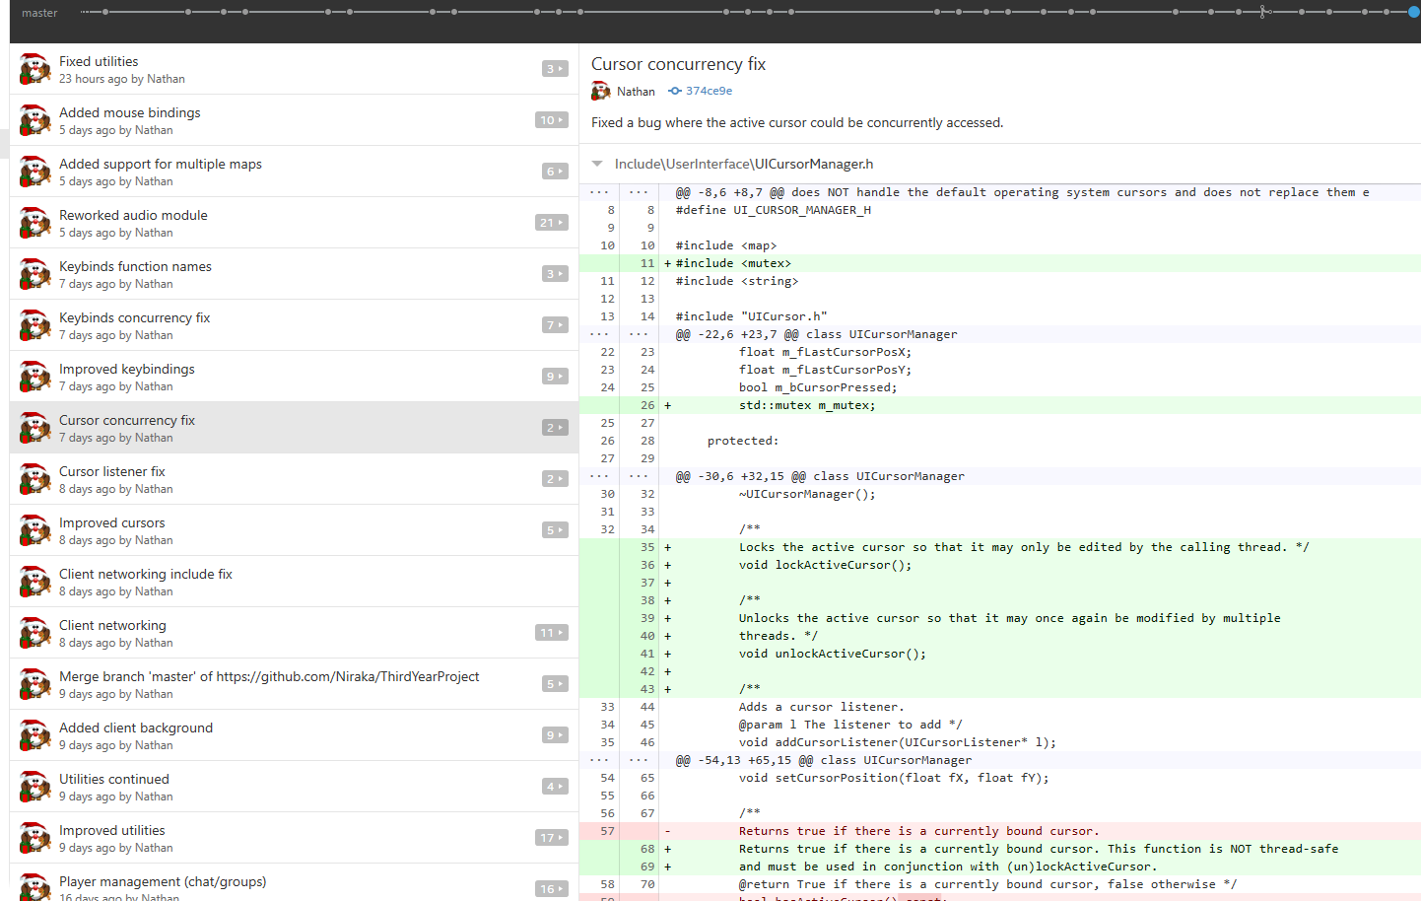

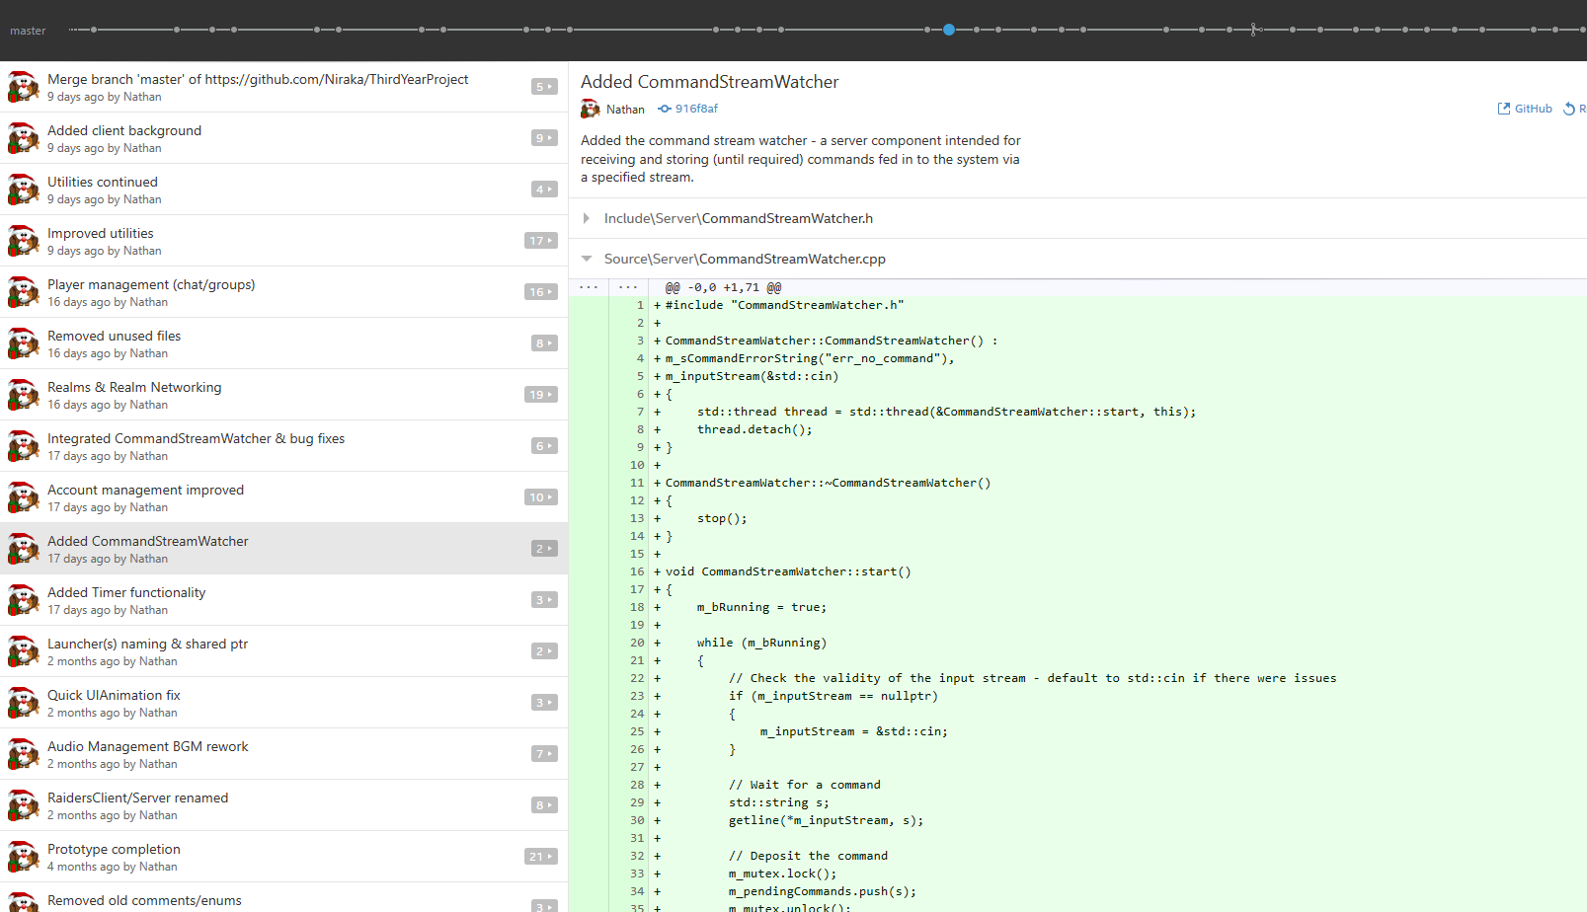

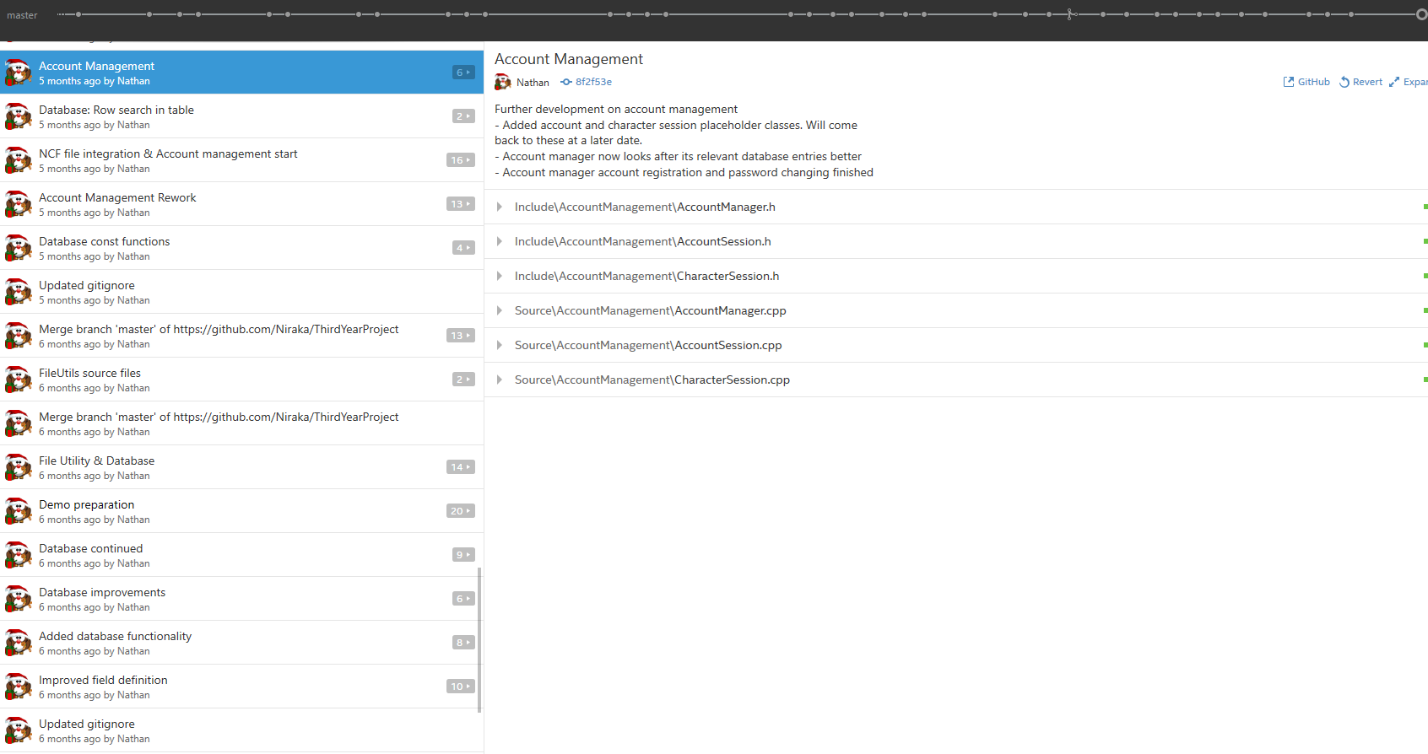

**12.2.2 Gantt chart**

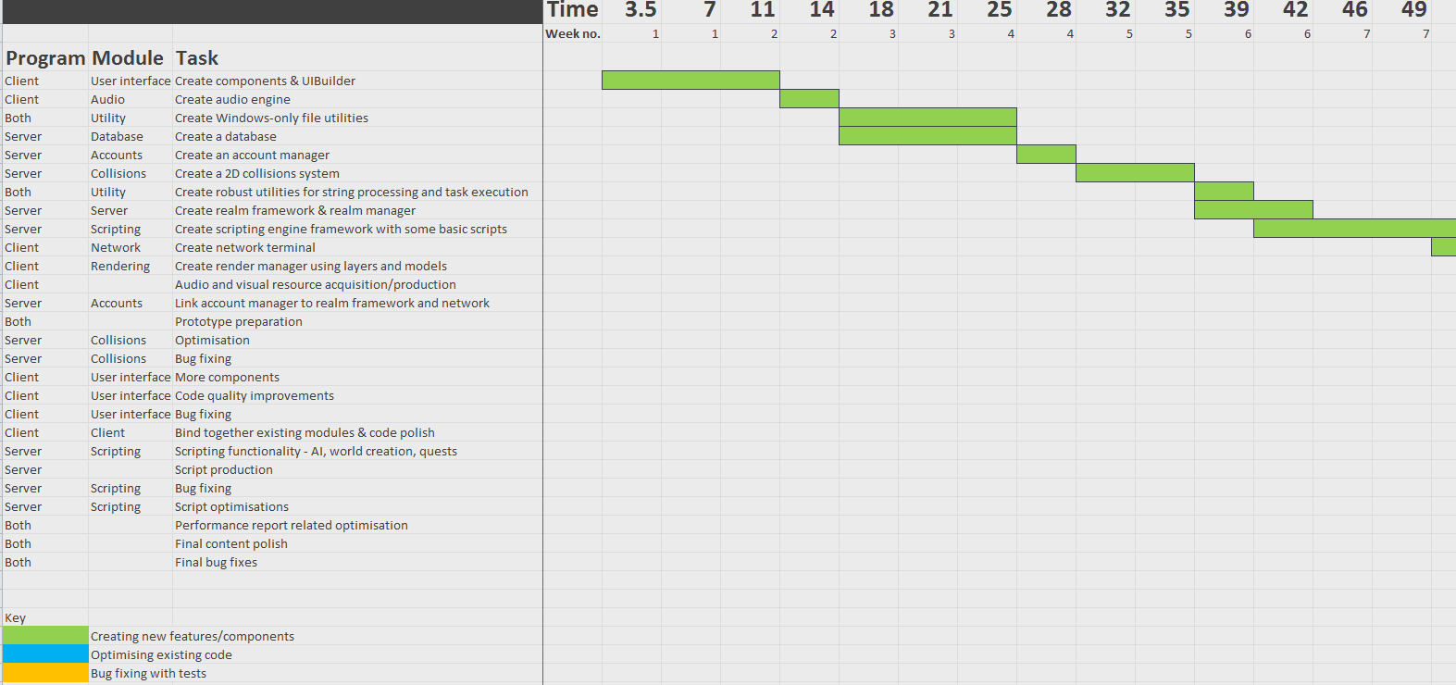

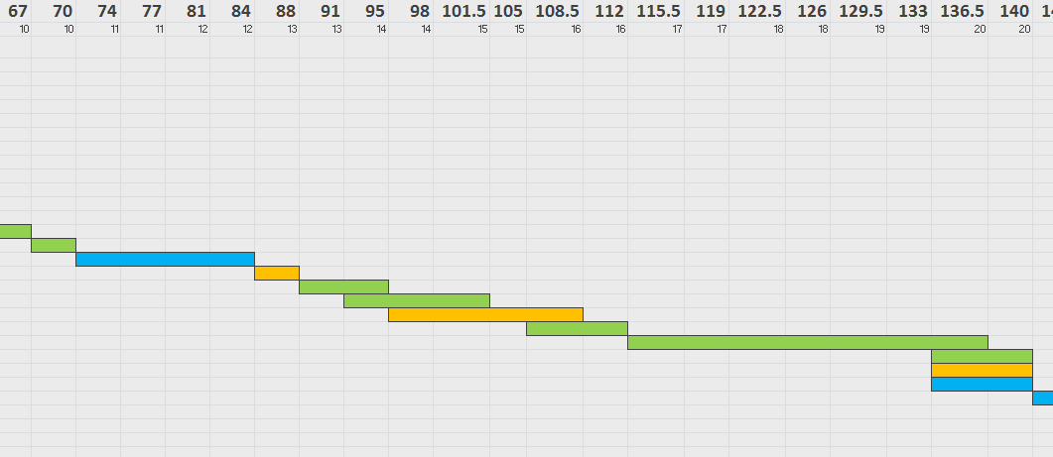

**12.2.3 Functional requirements specification**

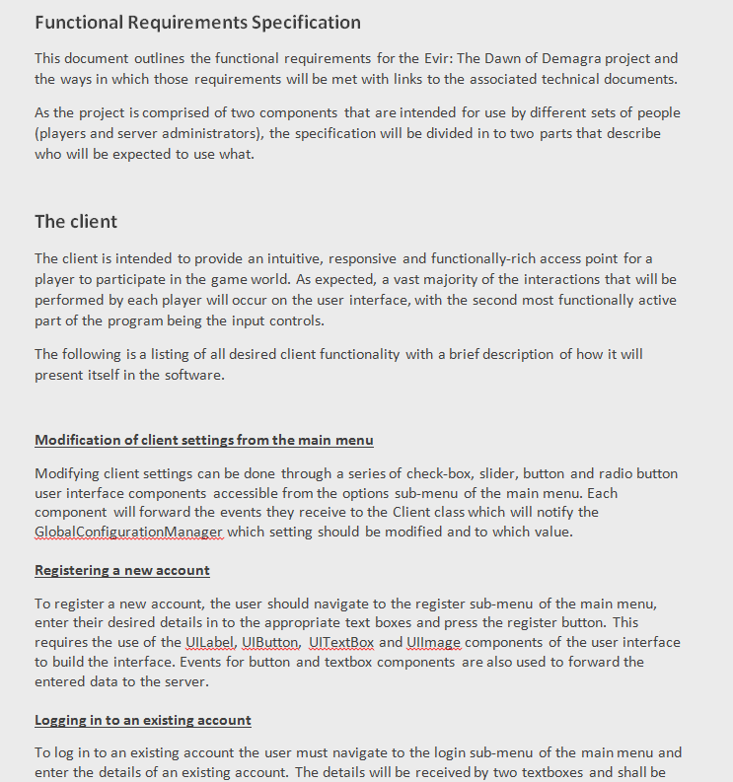

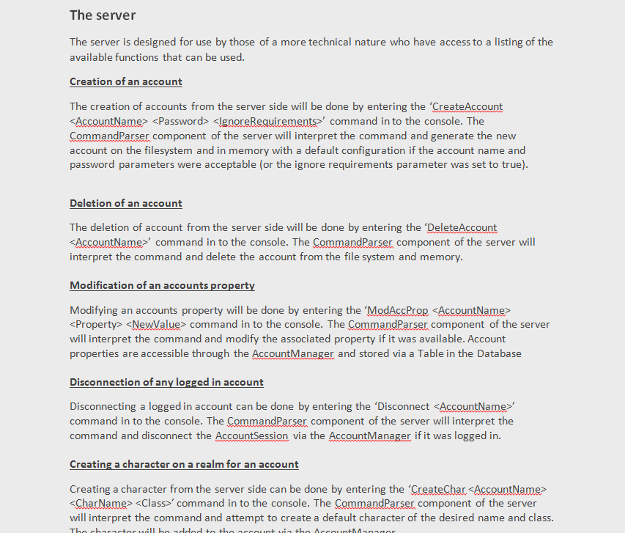

### 12.3 Gameplay design and development appendices

**12.3.1 Game design document (Overview)**

Evir:

The Dawn of Demagra

Game design document

Overview

|  |  |
| --- | --- |
| **Name:** | **Evir: The Dawn of Demagra** |
| **Target platforms:** | **PC (Windows)** |
| **Target age group:** | **Ages 15-25** |
| **Intended ESRB rating:** | **T (Teen)** |

**Gameplay story:**

The Elevians, a human-like race of beings, had lived in relative harmony for the past 150 years, disrupted only by the skirmishes of the creature’s native to the discovered regions of the world. However, a new potential threat unlike those of any recent time emerges from the darkest corners of their home world, Elesta Evir, and seeks to endanger the entire planet with his insane magical exploits. Despite the confident nature of the Elevian people, even they understand that confronting a foe capable of such magic without assistance is nothing short of a suicidal expedition. And so the story begins in the heart of the discovered world, where you, the player, must work together with an elite team of high profile characters to enlist the help of one of the most powerful demi-gods known to exist in the mortal plane – Nemora.

**Gameplay Summary:**

Getting involved is as simple as creating a character on one of the many realms available with your own personal customisations ranging anywhere from class, to hairstyle, to name. Once created, jump straight in to the game world and begin to explore and conquer the vast variety of quests, skills and dungeons that are on offer using all of the tools at your disposal. Make use of your fellow players, or take on the world alone. Complete the main story line or help out at a local farm in one of the many side quests available. Craft powerful weapons and armour and become a warrior of unmatched strength – or simply get rich! Evir seeks to combine all the components of a traditional RPG with the look, feel and explosive combat of a modern computer game.

**Unique Selling Points:**

* Group or solo play in a multiplayer universe.
* A persistent game world that continues to thrive even when no players are logged on.
* A modern slick user interface that takes inspiration from Sword Art Online.
* A range of classes to play, each with their own distinct play-styles.
* Skill-shot dependent combat. No ‘locked on’ abilities.
* An ever progressing story that players can experience at their own pace

**Competing products:**

|  |  |
| --- | --- |
| Realm of the Mad God | A 2D MMO focused on combat with perma-death |
| Runescape | A 3D browser or client MMO with an emphasis on questing and training a variety of skills |
| TERA | A 3D desktop client MMO with fast paced combat and modern graphics in an expansive world |

**12.3.2 Game design document (Content)**

Evir:

The Dawn of Demagra

Game design document

Content

# Contents

|  |  |
| --- | --- |
| Story & Characters | 3 |
| Environment design | 6 |
| Gameplay | 14 |
| Art | 30 |
| Audio | 31 |
| User interface | 33 |
| Control scheme | 38 |
| Terminology | 39 |

# Story

The game takes place in a world called Elesta Evir, and features a race of human-like beings that refer to themselves as Elevians. The world name originates from a combination of the name of the first established city (Elesta) and the Elevian translation of the word ‘eternal’ (Evir).

The Elevians had lived in relative harmony for the past 150 years, disrupted only by the skirmishes of the creature’s native to the discovered regions of the world. However, a new potential threat unlike those of any recent time emerges from the darkest corners of Evir and seeks to endanger the entire planet with his insane magical exploits. Despite the confident nature of the Elevian people, even they understand that confronting a foe capable of such magic without assistance is nothing short of a suicidal expedition. And so the story begins in the heart of the discovered world, where you, the player, must work to enlist the help of one of the most powerful demi-gods known to exist in the mortal plane – Nemora.

#### Story progression

This section details the order of events that the player will experience. Whilst it is possible for the player to roam mostly freely about the world and take on a large number of miscellaneous quests, the ‘main’ story line must occur in the order listed below:

* The player starts off in a small town in Everfall Forest, enacting the lifestyle of a simple citizen.
* Recruitment officers are seen visiting the town, requesting assistance to battle an “emerging threat”
* The player eventually joins the ranks, and is given some basic tasks to prove that he will not simply topple over in the first battle he is assigned.
* Once the basic tasks have been completed, the officers appear impressed, and assign you a more difficult task.
* Once this task has been completed, the officers notice that you are quite a lot stronger than the average joe, and agree to send you to meet with the Queens Advisor in the capital city for a special mission.
* Upon arriving, the player will experience a series of dialogues amongst the Queen, her Advisor and the Guild Leader that explain where the emerging threat is coming from and what it is.
* Once these dialogues are over, the player is brought forward and mentioned as someone who is particularly capable of assisting.
* The player is eventually asked to collect a number of hard to acquire items from the 3 world zones that will assist in the creation of an orb that can be used to “convince an old acquaintance” to help out the Elevians with their problem. These items are an Essence of Night, an Ashen Orb and a Binding Crystal.
* The player is told to meet with 3 characters – an experienced alchemist, an experienced blacksmith and a wise shaman, each of which will help the player acquire an item.
* Each character gives you a set of quests that must be completed before returning to the Advisor.
  + Wise shaman: Retrieve a binding crystal from a chest at the heart of an energy well located in southern Meridia
  + Experienced blacksmith: Forge an Ashen Orb from 12 Ashen bars and 3 Vials of Tainted Water from Everfall Overgrowth
  + Experienced alchemist: Requires an Essence of Night that can only be retrieved from summoning a creature in the middle of Zone3. The summoning process requires defeating 3 powerful creatures that randomly roam Zone3.
* Once these items have been gathered and returned to the Queens Advisor, you are congratulated, rewarded heavily, and told to meet the same characters at a location in north Zone3 for the binding ritual.
* Here, the player experiences the production of a Demagra Orb in a short cut scene that takes place in the world (all players can see it happening). The player will be challenged with defeating any nearby creatures that are drawn to the extreme energy that is produced by the ritual.
* Finally, the player is given the Orb by the Queen. She apologises for keeping the player in the dark for so long, and enters a dialogue that explains the situation and the task that lies before them.
* The next time the player enters Nemora’s Respite, the Queen will join the party and assist with the dungeon.
* Should the player defeat Nemora in the final boss battle, he will enter a dialogue with any players who are on the relevant quest and the Queen. The Queen will ask Nemora to contain himself within the Orb that the player holds so that he can be transported subtly to the location where the crazed Demagra exists.
* Nemora will accept this proposal, hinting at previous relations with the Queen, and will enter a short cut-scene of him entering the Orb.
* The games first chapter is now complete, and all characters involved will return to their places amongst the capital city.

#### Key Characters

**This section includes many missing names. They will be added over time.**

While many characters are simply citizens of the world and the towns that exist within it, some characters have meaningful storylines that are revisited or referenced several times throughout the game.

|  |  |
| --- | --- |
| Character | Who?? |
| You | A citizen of Evir who comes forth to reveal himself/herself as a powerful warrior |
| Nemora | A Demagra who prefers to keep to himself and resides deep within his respite. Nemora is the deceased father of the Queen who died casting a spell so strong that it takes it caster with it, effectively winning the Great War by destroying most of the high ranking enemy officers and their leader in one go. His soul was trapped in one of their corpses. |
| Queen | The queen of the Elevian’s. Very powerful but very reserved |
| Queens advisor | General advisor to the queen. Loyal and wise, but not particularly strong. Knows a great deal about the citizens of Evir and who can be of assistance in completing very specific tasks. |
| Guild leader | Leader of the guild of warriors. As strong as the queen and loyal to the crown. Other than appearing beside the Queen and in a number of dialogues, this character does not get too much screen time. He does help during the binding ritual, however. |
| Emerging threat | A newly born Demagra from the remains of a powerful wizard who committed suicide in an attempt to trap his soul in the body of a creature he created. Does not actually make an appearance in this chapter of the game. Rather, he is only spoken of. |

#### Races / Creatures

**This section includes many missing names. They will be added over time.**

**Norvik**

A race of creatures that live underground and have developed excellent hearing and manoeuvrability as a result. The Norvik tend to infest any tunnel network after a while and are a constant nuisance for any mining or construction operation. They range greatly in strength, from small rat-like creatures to large tunnel borers.

**Demagra**

A race of Demi-Gods who typically possess exceptional strength in a few specific areas.

* Each one looks different, relating to their strengths and personalities.
* Are born when a recently deceased soul of an exceptionally powerful person is locked inside a form.
* Live for several thousand years, but are not immortal.

**Shades**

A race of ghost-like beings that are drawn to energy sources that they feed off of. Shades reproduce by splitting in half once they overload with energy, making them very common at energy wells and near powerful wizards and creatures.

**Wildlife**

The wildlife of Evir ranges from boars to large cats and lizards to possessed plant creatures. The type of wildlife that exists within each region varies, but can often be determined by the type of terrain and people that live there.

**Elevian**

The race that the player plays as. A human-like species that have evolved to become stronger than a human physically, with at least 10% of the population being able to manipulate energy to cast magic spells of varying kinds.

# Environment design

The environment is constructed via a series of connected zones that can be traversed via portals located somewhere within the zone (typically near the edges). Adding or removing additional zones need only require a set of portals that link to the already accessible map.

**Tiles**

Each zone is made up of a very large number of tiles. A tile indicates the properties of the terrain and may apply statistical or atmospheric effects to the player based on type. The following is a list of all tile types and their applied effects:

|  |  |
| --- | --- |
| Type | Affect |
| Grass | None |
| Water | 40% movement speed slow |
| Wood flooring | None |
| Marble flooring | None |
| Mud | 10% movement speed slow |
| Cave | None |
| Stone | None |
| Stone structure | None |

Tiles may contain decoration such as flowers or cracks, but these do not have any implication on the effects of the tile. Other such decoration that can be used to populate the environment includes: trees, bushes, flowers, rocks, plants, logs, ruins, pillars, fences and irrigation.

**Resource nodes**

The environment also bares host to a number of ‘nodes’ that can be interacted with and will have a visual impact on the game world as a result. For example, ore or foraging bushes, once interacted with, will appear to be exhausted or will disappear altogether. The position of these nodes is randomised amongst a set of available positions. Nodes reappear or regain their resources after a certain amount of time.

**Zones**

There will be 6 zones available for play initially, 3 of which are a special kind of zone, called a dungeon. The available zones and some key points of interest can be seen as follows:

**Everfall Forest (Starting zone – levels 1 to 3)**

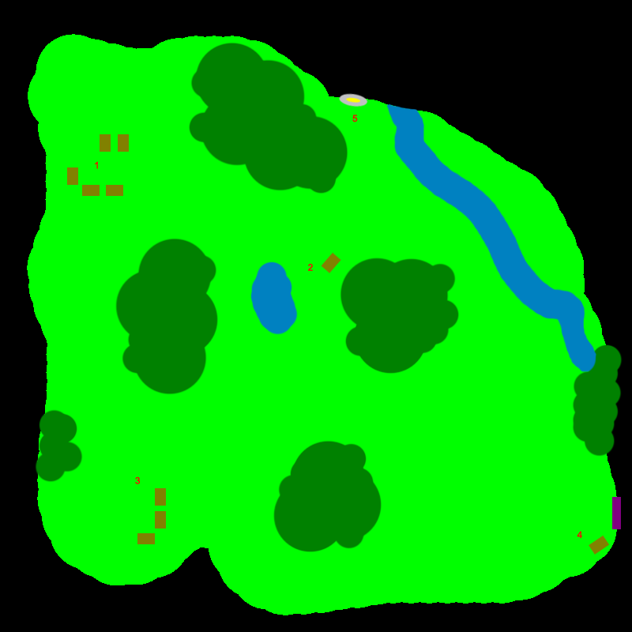

|  |  |
| --- | --- |
| Index | Description |
| 1 | Start point and starting town |
| 2 | Everfall Lake |
| 3 | Lumber camp |
| 4 | Portal to Meridia |
| 5 | Entrance to Everfall Overgrowth dungeon |

**Meridia (Zone 2 – Levels 4 to 7)**

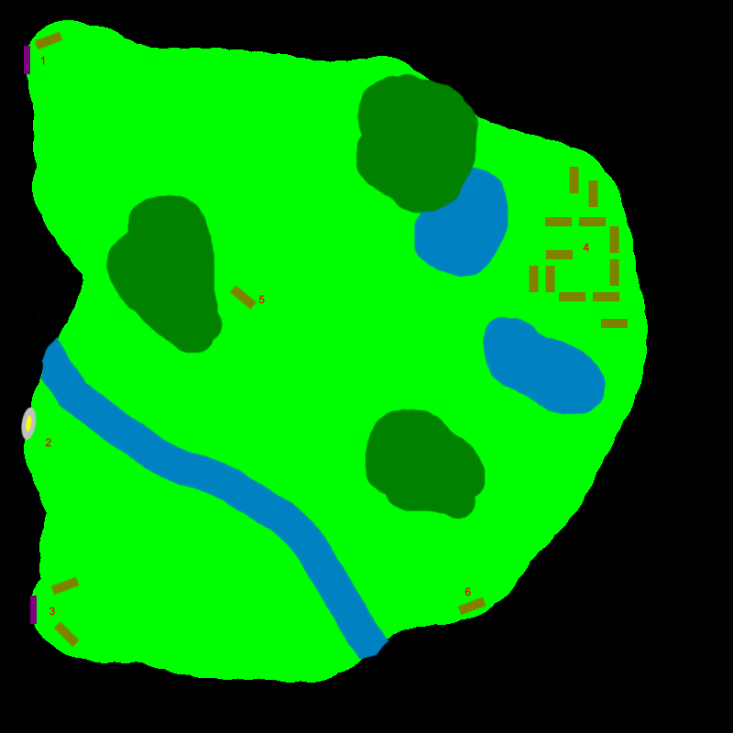

|  |  |
| --- | --- |
| Index | Description |
| 1 | Portal to Everfall Forest |
| 2 | Entrance to Burrows dungeon |
| 3 | Portal to Zone 3 |
| 4 | Elesta, capital city |
| 5 | Questing point |
| 6 | Questing point |

**Zone 3 (Zone 3 – Levels 8 – 10)**

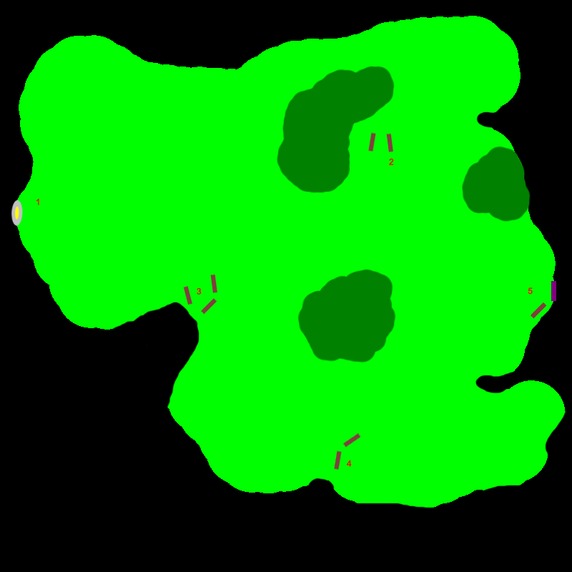

|  |  |
| --- | --- |
| Index | Description |
| 1 | Entrance to Nemora’s Respite dungeon |
| 2 | Questing point |
| 3 | Questing point |
| 4 | Questing point |
| 5 | Portal to Meridia |

**Dungeons**

A dungeon is a special kind of zone that is intended for play by 2-4 people at any given time. Dungeons typically contain enemies and rewards that are much stronger than any one player is capable of defeating on their own without a significant level or equipment advantage.

Dungeons are different to zones in that there may be multiple instances of them alive serving any number of groups of players at a time. Each group of players plays in their own instance, with their own set of enemies and rewards, and cannot transfer among instances without joining the group of another set of players and re-entering the dungeon.

When a player enters a dungeon, depending on group status, one of the following will happen:

1. If the player is a member of a group, the player will join the instance of the dungeon that belongs to the group leader. If no such instance existed, it is created on behalf of the group leader.
2. If the player is a group leader **and** no members are currently inside the dungeon, a new dungeon instance is created with a fresh state. This includes populating the dungeon with a fresh set of enemies and rewards.
3. If the player is a group leader **and** members are currently inside the dungeon, the player will join his group in the existing dungeon instance.

Note that this means that as soon as all players of a group leave a dungeon, the instance will be lost and a new one will be recreated on entering. This allows groups to complete a dungeon multiple times very quickly if they choose to do so.

**Everfall Overgrowth**

A dungeon set in an overgrown area of Everfall Forest that houses some plants and animals that are getting a bit too big for their boots. Mostly an introduction to the format of dungeons.

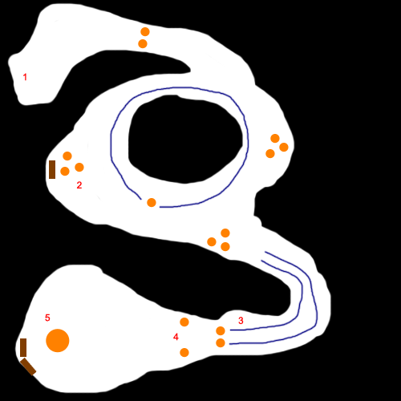

|  |  |
| --- | --- |
| Index | Description |
| 1 | Entrance/exit |
| 2 | Optional enemies guarding a chest |
| 3 | Patrolling enemies that wander the corridor |
| 4 | A particularly strong pair of enemies |
| 5 | The final boss |

**Burrows**

A series of wildly interconnected tunnels and chambers frequently traversed by a species of nasty underground creatures. Features randomised spawning and time-dependant movement.

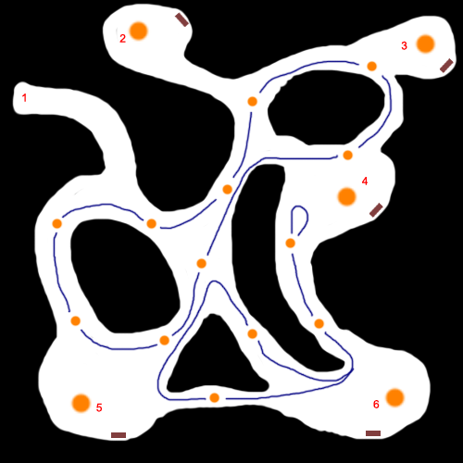

|  |  |
| --- | --- |
| Index | Description |
| 1 | Entrance/exit |
| 2 | A mini-boss. 50% chance to spawn. |
| 3 | A mini-boss. Spawns if boss #2 doesn’t. |
| 4 | A mini-boss. 50% chance to spawn. |
| 5 | A mini-boss. Spawns if boss #4 doesn’t. |
| 6 | The final boss |

**Nemora’s Respite**

An ‘end-game’ dungeon that features challenging events, traps and unique enemies. Defeating Nemora is the equivalent of winning the game. This one is hard.

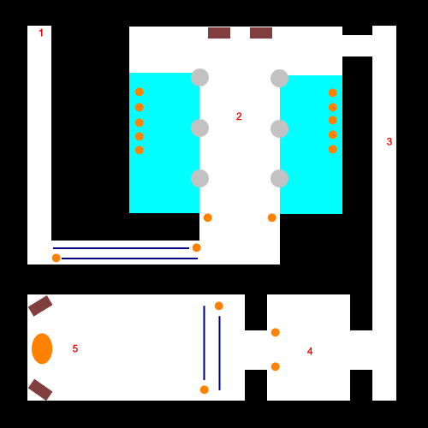

|  |  |
| --- | --- |
| Index | Description |
| 1 | Entrance/Exit |
| 2 | A gauntlet event. Enemies positioned within the water to the sides periodically awaken and assault the group. Try not to be overrun. |
| 3 | Hallway containing various deadly traps, but no real enemies |
| 4 | A particularly challenging set of enemies |
| 5 | Nemora, the final boss of the game |

# Gameplay

#### Equipment

**Acquisition**

A player can acquire equipment in the form of armour and weapons throughout the game to increase the strength of their character through various statistical increases.

Acquiring equipment can be done in any of the following ways:

* Received as a reward for completing a quest
* Purchased from an NPC vendor in exchange for some currency
* Crafted via blacksmithing or weapon forging
* Looted from the remains of a defeated enemy
* Looted from a chest
* Or picked up from the ground from where another player has placed it

**Categories**

Each piece of equipment has a category that determines which part of the player the item will be equipped to. Naturally, only one item from each category may be equipped at any one time. These categories are:

* Main hand
* Off hand
* Head
* Shoulders
* Chest
* Legs
* Feet
* Hands
* Back

Any item that does not adhere to one of these categories is deemed unwearable

**Restrictions**

Some items come with an additional set of restrictions that limit a player’s ability to equip an item. Usually, these restrictions come in the form of a minimum player level, blacksmithing level or weaponry level. Once these requirements have been met, the player may equip the item via the normal process. Generally, these restrictions are reserved for “higher level” items that are not intended for equipping without first putting in some sort of work. In rarer cases, an item may have a restriction that requires the completion of a particular quest or the slaying of a particular enemy.

Items may not be equipped while in combat.

Equipping items may not push the player over their maximum carry weight.

**Stat bonuses**

Each item can come with one or more stat bonuses that increase the player’s strength in one area or another whilst they are equipped. The strength of the stats that can be found on an item increase as the tasks needed to acquire the item become more difficult.

For RPG purposes, some item categories are likely to provide a greater amount of stats in general to conform to the area of the body that they will occupy. For example, a weapon or chest piece will possess at least 50% more statistical strength than a pair of boots.

Notably, some stat bonuses will not provide as much of a benefit to some classes as they will to another, as some classes make better use of certain stats. See the stats section for more information.

**Crafting**

Armour can be crafted using the blacksmithing skill when within a reasonable distance of a forge. Weaponry can be crafted using the weapon forging skill when within a reasonably distance of the relevant tool (Crafting bench for bows, forge for swords or altar for magic orbs). Crafting equipment is a time consuming but rewarding method of acquiring gear, and will often result in items above average for the level of the player.

#### Inventory & weight

Each item in the game world has a weight value. Acquiring that item and storing it in the inventory **or equipping it** will increase the players total carry weight by the weight value of the item. Once the player has reached their maximum weight value, they will not be able to pick up or equip any more items until either the maximum carry weight is increased or adequate weight is discarded by removing items from the player’s possession.

Note that the carry weight of a player will have an effect on their movement speed, ranging from fastest at NoImpactCarryWeight to 20% slower at maximum capacity. (See stats section)

The total carry weight can be calculated using the following formula:

65 + (5 * level) + additional bonuses

The movement speed impact can be calculated using the following formula (when above NoImpactCarryWeight):

((Current Carry Weight - NoImpactCarryWeight)) / (Maximum Carry Weight - NoImpactCarryWeight)) * Maximum Movement Speed Reduction

Certain perks are able to reduce the movement speed impact.

#### Map

**Zones**

The world map, when opened, displays the map for the zone that you are currently in, with your current position as the focal point. To view other zones, the player can select the name of the desired zone from a list of discovered zones. Once a zone is discovered for the first time, it is added to the list and may be viewed at any time.

**Icons**

A world map contains a series of icons that can be toggled on or off that indicate the position of certain landmarks, NPCs or objectives. These icons are as follows:

|  |  |
| --- | --- |
| Icon | Indicates |
| Bed | Inn |
| Exclamation | Quests available |
| Horse | Fast travel |
| Cave entrance | Dungeon |

#### Levelling (Character level)

A new character starts at level 1.

**Earning experience**

Players may earn experience for their character by doing any of the following:

* Completing a quest
* Killing an enemy
* Crafting an item
* Completing a dungeon

Once enough experience has been accumulated, the player will level up. Upon levelling up, the following will occur:

* Player level increases by 1
* One skill point will be awarded
* Current experience will be reset, with any excess experience overflowing in to the next level
* A new maximum experience value will be set if the player was less than the maximum level
* A congratulatory message will be displayed in chat

**Maximum level**

Once the player reaches the maximum level (8), no more experienced may be earned.

#### Stats

All NPC and player characters have a set of statistics that determine their strength in the game. Each stat has many effects on the character, but most of them are combat orientated. Additionally, some stats benefit some character types more than others due to the skillset they yield.

|  |  |  |  |
| --- | --- | --- | --- |
| Stat | Description | Base value | Maximum value |
| Health | The amount of damage a unit can sustain before dying. Regenerates naturally over time | 300 + (20 * level) | N/A |
| Health regeneration | Regenerates health every second | 0.9 + (0.1 * level) | 10% of max health |
| Energy | Consumed for casting abilities. Regenerates naturally over time | 100 | N/A |
| Energy regeneration | Regenerates energy every second | 9 + (1 * level) | 100% of max energy |
| Magic Resist | Reduces magical damage by X points | 16 + (4 * level) | N/A |
| Armour | Reduces physical damage by X points | 16 + (4 * level) | N/A |
| Physical power | Increases the amount of physical damage you deal | 20 + (3 * level) | N/A |
| Magical power | Increases the amount of magical damage you deal | 20 + (3 * level) | N/A |
| Attack speed | Reduces the time between each physical attack | 1.5 seconds - (0.05 * level) | 0.5 |
| Cooldown reduction | Reduces the cooldown time of abilities | 0% | 50% |
| Movement speed | Increases your movement speed | 20 | 100 |
| Carry weight | Increases the total weight of the items you can carry and equip | 65 + (5 * level) | N/A |
| No impact carry weight | Increases the weight threshold under which movement speed reductions will start being applied | 30 + (3 * level) | 100% of max carry weight |

**Bonuses**

On top of the base stats detailed above, each character is able to increase their stats using equipment, passive effects or buffs. Bonuses may not cause values to exceed their maximum values.

#### Skills

Each player character has access to a range of skills that allow them to do different things. Each skill starts at level 1 and can increase up to level 10.

**Levelling up skills**

Levelling up skills is done by earning experience through completing the relevant action of the skill. Once your current experience exceeds the maximum experience for the skill level, the skills levels up, and performs the following actions:

* Skill level increases by 1
* Current experience will be reset, with any excess experience overflowing in to the next level
* A new maximum experience value will be set if the skill was less than the maximum level
* A congratulatory message will be displayed in chat

10% of all experience earned on skills is also applied to player level, symbolising a players ‘general growth’ through perfecting skills.

Earning level 10 in a skill typically awards a large reward.

**Skill listing**

These are the available skills, each with a set of actions that award experience and the rewards for levelling them up. Note that all listed rewards are added and do not overwrite previous rewards.

**Mining**

A skill for extracting ore and gems from ore nodes. Ore can be smelted in to bars at a forge that can then be used for blacksmithing and weapon forging.

|  |  |  |
| --- | --- | --- |
| Skill level | Experience award by... | Reward for level |
| 1 | Mining ore, Smelting ore |  |
| 2 | Mining ore, Smelting ore | +8% resources harvested |
| 3 | Mining ore, Smelting ore | +2% chance to find vendorable gems |
| 4 | Mining ore, Smelting ore | +12% resources harvested |
| 5 | Mining ore, Smelting ore | +2% chance to find vendorable gems |
| 6 | Mining ore, Smelting ore | +14% resources harvested |
| 7 | Mining ore, Smelting ore | +2% chance to find vendorable gems |
| 8 | Mining ore, Smelting ore | +16% resources harvested |
| 9 | Mining ore, Smelting ore | +2% chance to find vendorable gems |
| 10 |  | +100% resources harvested |

**Blacksmithing**

A skill for the production of armour that the player can equip or sell. Utilises metal bars, a variety of other resources and a blacksmithing workstation.

|  |  |  |
| --- | --- | --- |
| Skill level | Experience award by... | Reward for level |
| 1 | Crafting armour |  |
| 2 | Crafting armour | Crafted armour is 2% stronger |
| 3 | Crafting armour | Crafted armour is 2% stronger, can create tier 2 armour |
| 4 | Crafting armour | Crafted armour is 2% stronger |
| 5 | Crafting armour | Crafted armour is 2% stronger, can create tier 3 armour |
| 6 | Crafting armour | Crafted armour is 2% stronger |
| 7 | Crafting armour | Crafted armour is 2% stronger, can create tier 4 armour |
| 8 | Crafting armour | Crafted armour is 2% stronger |
| 9 | Crafting armour | Crafted armour is 2% stronger |
| 10 |  | Crafted armour is 30% stronger, can create tier 5 armour |

**Weapon forging**

A skill for the production of weaponry such as swords, shields, bows and magic orbs. Utilises metal bars, a variety of other resources and a weapon forging workstation.

|  |  |  |
| --- | --- | --- |
| Skill level | Experience award by... | Reward for level |
| 1 | Crafting weaponry |  |
| 2 | Crafting weaponry | Crafted weaponry is 2% stronger |
| 3 | Crafting weaponry | Crafted weaponry is 2% stronger, can create tier 2 weaponry |
| 4 | Crafting weaponry | Crafted weaponry is 2% stronger |
| 5 | Crafting weaponry | Crafted weaponry is 2% stronger, can create tier 3 weaponry |
| 6 | Crafting weaponry | Crafted weaponry is 2% stronger |
| 7 | Crafting weaponry | Crafted weaponry is 2% stronger, can create tier 4 weaponry |
| 8 | Crafting weaponry | Crafted weaponry is 2% stronger |
| 9 | Crafting weaponry | Crafted weaponry is 2% stronger |
| 10 |  | Crafted weaponry is 30% stronger, can create tier 5 weaponry |

**Foraging**

A skill for the acquisition of ingredients that can be used in the production of potions with varying effects. Ingredients can be prepared at an alchemist’s workstation. Some ingredients such as berries have a chance to be instantly consumable to restore health or provide small temporary buffs.

|  |  |  |
| --- | --- | --- |
| Skill level | Experience award by... | Reward for level |
| 1 | Foraging in bushes, grasses or water. Cleaning & preparing ingredients |  |
| 2 | Foraging in bushes, grasses or water. Cleaning & preparing ingredients | +4% resources harvested |
| 3 | Foraging in bushes, grasses or water. Cleaning & preparing ingredients | +10% chance harvested resources are instantly consumable |
| 4 | Foraging in bushes, grasses or water. Cleaning & preparing ingredients | +6% resources harvested |
| 5 | Foraging in bushes, grasses or water. Cleaning & preparing ingredients | Can find powerful ingredients |
| 6 | Foraging in bushes, grasses or water. Cleaning & preparing ingredients | +7% resources harvested |
| 7 | Foraging in bushes, grasses or water. Cleaning & preparing ingredients | +20% chance harvested resources are instantly consumable |
| 8 | Foraging in bushes, grasses or water. Cleaning & preparing ingredients | +8% resources harvested |
| 9 | Foraging in bushes, grasses or water. Cleaning & preparing ingredients | +30% chance harvested resources are instantly consumable |
| 10 |  | +50% resources harvested, can find very powerful ingredients |

**Alchemy**

A skill for the production of consumable potions or foods that provide buffs on use. Requires ‘prepared’ or ‘cleaned’ foraged resources, a variety of other resources and an alchemist’s workstation.

|  |  |  |
| --- | --- | --- |
| Skill level | Experience award by... | Reward for level |
| 1 | Crafting potions or foodstuffs |  |
| 2 | Crafting potions or foodstuffs | Crafted potions are 2% more potent |
| 3 | Crafting potions or foodstuffs | More potion and foodstuffs available |
| 4 | Crafting potions or foodstuffs | Crafted potions are 4% more potent |
| 5 | Crafting potions or foodstuffs | More potion and foodstuffs available |
| 6 | Crafting potions or foodstuffs | Crafted potions are 6% more potent |
| 7 | Crafting potions or foodstuffs | More potion and foodstuffs available |
| 8 | Crafting potions or foodstuffs | Crafted potions are 8% more potent |
| 9 | Crafting potions or foodstuffs | More potion and foodstuffs available |
| 10 |  | Crafted potions are 50% more potent |

#### Quests

A quest is one or more objectives that are assigned by an NPC or interactable object that can be completed in exchange for some form of reward.

* Any NPC or object with an exclamation mark above their head is offering a quest
* A player may accept a quest only once. The quest may only be re-accepted from the location it was first acquired if the quest is abandoned.
* A player may store up to 10 active quests at once
* Only one quest may be tracked on the interface at once

Quests may occur in multiple parts, but generally do not. In the event of multiple parts, the quest will state whether one objective must be completed before the other, or whether parts can be completed concurrently.

Objectives are split in to the following categories:

* Kill – Requires killing X number of Y creatures
* Collect – Requires collecting and returning to the quest giver, X amount of Y items (obtained through any means unless otherwise specified)
* Deliver – Take an item from one place to another safely
* Escort – Take an NPC from one place to another safely
* Meet – Meet and engage with an NPC at a destination location

Once a quest has been completed, it can be returned to the specified quest hand in point (detailed in the quest description) in exchange for rewards. These rewards can be any of the following and correspond to the difficulty of the tasks involved:

* Experience – Awarded either to the player or to a skill
* Equipment – A weapon or piece of armour
* Coin – Spendable currency
* Buff – A temporary buff. Typically these buffs are dependent on being in the location that the quest occurred or have a much longer duration to compensate for only being available once the quest has been completed.

#### Crafting

Crafting is the means by which a player may create items. Crafting depends on the players’ skills in their respective areas to provide access to items. As a skill rises, more items will be able to be crafted.

To craft an item, players must use the crafting menu when within range of the appropriate crafting facilities. The items for the crafting procedure must be present in the players’ inventory.

|  |  |
| --- | --- |
| Crafting | Facility |
| Blacksmithing | Blacksmithing workstation |
| Weapon forging | Weapons forge |
| Alchemy | Alchemists lab |

**Blacksmithing**

Allows the creation of armour. Some examples of the items that can be crafted are listed below with more to be added in the future:

|  |  |  |  |
| --- | --- | --- | --- |
| **Item name** | **Skill req.** | **Material req.** | **Additional req.** |
| Bronze chest piece | 2 | 6 bronze bars |  |
| Iron chest piece | 4 | 6 iron bars |  |
| Ashen chest piece | 8 | 6 ashen bars |  |

**Weapon forging**

Allows the creation of bows, swords, daggers, axes, shields and magic orbs. Some examples of the items that can be crafted are listed below with more to be added in the future:

|  |  |  |  |
| --- | --- | --- | --- |
| **Item name** | **Skill req.** | **Material req.** | **Additional req.** |
| Bow | 1 | 2 string, 2 bronze bars, 2 wooden supports |  |
| Iron Sword | 3 | 5 iron bars, 1 wooden support |  |
| Moonblade | 9 | 2 moonshard, 1 night essence, 10 reinforced ashen bars | Dungeon completed: ‘Nemora’s Respite’ |

**Alchemy**

Allows the creation of food and potions that provide short term buffs. Some examples of the items that can be crafted are listed below with more to be added in the future:

|  |  |  |  |
| --- | --- | --- | --- |
| **Item name** | **Skill req.** | **Material req.** | **Additional req.** |
| Health potion | 2 | 2 boogle berries, 1 swamproot | N/A |
| Energy potion | 2 | 2 yumbo berries, 1 swamproot | N/A |
| Fury potion | 7 | 1 Ingars Special Powder, 1 Vial of Liquid Energy | Completed quest: ‘Ingar Needs Assistance’ |

#### Classes (Includes abilities, base stats and talents)

A class is selected at the start of the game in the character creation menu. Once selected, there is absolutely no point at which the class can be changed.

A class, short for classification, indicates the playstyle, ability set and theme of the players’ character.

The following classes are available:

**Wraith**

The wraith combines fast movement with focused attacks to deal heavy damage before their opponents have much opportunity to strike back.

**Profile**

|  |  |
| --- | --- |
| Playstyle | Agile, opportunistic |
| Melee/ranged? | Hybrid |
| Strengths | High burst damage, hard to hit |
| Weaknesses | Low survivability, long cooldowns |
| Primary stats | Physical damage, movement speed |
| Primary damage type | Physical |

**Base stat modifications**

|  |  |
| --- | --- |
| Health | 0 |
| Health regeneration | 0 |
| Energy | 0 |
| Energy regeneration | +3 |
| Magic Resist | 0 |
| Armour | +1 |
| Physical power | +5 |
| Magical power | 0 |
| Attack speed | -0.1 |
| Cooldown reduction | 0 |
| Movement speed | +5 |
| Carry weight | 0 |
| No impact carry weight | 0 |

**Abilities**

|  |  |  |
| --- | --- | --- |
| Ability | Learnt at level | Description |
| Stab | 1 | Stabs the target, dealing physical damage and applying 1 stack of physical weakness |
| Slash | 2 | Slashes the target, dealing physical damage |
| Revitalise | 3 | Restores health to yourself |
| Rush | 5 | Increases movement speed and attack speed for 5 seconds |
| Vanish | 6 | Becomes invisible for a short duration, confusing enemies that are targeting you and double the damage of your next stab or slash |
| Venom | 7 | Your next attack applies a poison to the target |
| Ghost Form | 9 | Enter ghost form, reducing the energy cost and cooldown of all spells for a short duration. Also increases armour and magic resistance by a small amount. |

**Talents**

|  |  |  |
| --- | --- | --- |
| **Name** | **Requirements** | **Effect** |
| Precision | Level 1 | Deals X% more damage |
| Striking | Level 1 | Attack speed is increased by X% |
| Long Reach | Level 2 | Slash has a longer range |
| Evasive | Level 3 | Enemies are less likely to attack you over other nearby targets |
| Replenishing | Level 4 | Revitalise costs less energy |
| Quiet steps | Level 4 | Nearby enemies are less likely to engage you |
| Penetrating blows | Level 5 | Slash benefits more from physical weakness affects |
| Deep Wounds | Level 5 | Stab can stack more physical weakness debuffs |
| Unseen Blade | Level 8 | Stab does more damage to targets that are not facing you |
| Warming Shadows | Level 6 | Vanish restores a portion of your missing health |
| Enhanced Poisons | Level 7 | Poisons deal more damage |
| Intoxicating Poisons | Level 7, Enhanced poisons | Poisons last longer |
| Deadly Poisons | Level 7, Enhanced poisons | Poisons deal more damage the longer they are active |
| Wraith Form | Level 10 | Ghosting increases movement speed and attack speed |

**Mage**

The mage utilises magical energy to control and destroy their opponents from a distance. The class focuses on area of effect (AoE) spells and exposing weaknesses in their enemies’ defences with debuffs.

**Profile**

|  |  |
| --- | --- |
| Playstyle | Controlled, calculated |
| Melee/ranged? | Ranged |
| Strengths | High control, affects multiple targets, good combos |
| Weaknesses | Low survivability, some longer cooldowns, easy to run out of energy |
| Primary stats | Magical power, cooldown reduction, energy, energy regeneration |
| Primary damage type | Magical |

**Base stat modifications**

|  |  |
| --- | --- |
| Health | 0 |
| Health regeneration | 0 |
| Energy | +10 |
| Energy regeneration | 0 |
| Magic Resist | 0 |
| Armour | 0 |
| Physical power | 0 |
| Magical power | +3 |
| Attack speed | 0 |
| Cooldown reduction | 0 |
| Movement speed | 0 |
| Carry weight | +5 |
| No impact carry weight | +5 |

**Abilities**

|  |  |  |
| --- | --- | --- |
| Ability | Learnt at level | Description |
| Fire lance | 1 | Launches a fire lance in the target direction that deals damage to the first enemy hit and applies a burn |
| Infuse | 2 | Infuses your next spell, increasing its energy cost by and damage |
| Combustion | 3 | Emits a ring of damaging energy from the position of the caster that slows and damages enemies. Affects are tripled against burning targets. |
| Restore | 4 | Emits a ring of healing energy from the position of the caster, restoring health and increasing armour and magic resistance for a short duration |
| Pulse | 5 | Emits a pulse of energy in a frontal cone from the position of the caster. Enemies take damage and lose magic resistance for a few seconds (Stacking up to 3 times). |
| Vortex | 7 | Creates a vortex at the target location for a few seconds. Enemies inside the vortex take damage every second. |
| Astral alignment | 9 | Summons 3 micro-stars around the caster. For every star the caster remains within a short distance of, the caster will receive a temporary buff. |

**Talents**

|  |  |  |
| --- | --- | --- |
| **Name** | **Requirements** | **Effect** |
| Burning Rush | Level 1 | Applying a burn to an enemy temporarily grants you movement speed for 2 seconds. |
| Pyromaniac | Level 5, Burning Rush | Fire Lance launches two consecutive lances, but costs more |
| Afterburner | Level 2, Burning Rush | Grants additional MagicPower while Burning Rush is active |
| Mysticism | Level 2 | Grants additional MagicPower |
| Arcane Arts | Level 2 | Grants cooldown reduction |
| Preservation | Level 4 | Restore heals you for more |
| Arcane Bubble | Level 6 | Restore applies a shield to all affected targets for a portion of the health it restored |
| Energy Spiking | Level 5 | Doubles the cooldown, energy cost increase and damage of Infuse |
| Power Overwhelming | Level 10, Energy Spiking | Infuse now affects the next 3 spells |
| Force Pulse | Level 3 | Increases the range of Pulse |
| Focus Pulse | Level 5, Force Pulse | Pulse stacks up to 5 times and lasts longer |
| Magic Compression | Level 2 | Increases carry weight |
| Magic Compression 2 | Level 4, Magic Compression | Further increases carry weight |
| Harvester | Level 1 | Energy regenerates faster |

**Mercenary**

The mercenary is a powerful melee fighter who specialises in getting in to the heat of the battle and going blow for blow with enemies. What this class lacks in control it makes up for in durability.

**Profile**

|  |  |
| --- | --- |
| Playstyle | Aggressive, gung-ho, durable |
| Melee/ranged? | Melee |
| Strengths | Durable, good damage |
| Weaknesses | Easily controlled, low control |
| Primary stats | Physical power, armour, magic resist, health |
| Primary damage type | Physical |

**Base stat modifications**

|  |  |
| --- | --- |
| Health | +40 |
| Health regeneration | +0.2 |
| Energy | 0 |
| Energy regeneration | 0 |
| Magic Resist | +2 |
| Armour | +2 |
| Physical power | +1 |
| Magical power | 0 |
| Attack speed | 0 |
| Cooldown reduction | 0 |
| Movement speed | 0 |
| Carry weight | +10 |
| No impact carry weight | +20 |

**Abilities**

|  |  |  |
| --- | --- | --- |
| Ability | Learnt at level | Description |
| Crush | 1 | Crushes targets in a cone in front of you, applying a bleed affect to all those affected |
| Charge | 2 | Charges forth, ramping up movement speed over time and stunning the first enemy you collide with |
| Block | 3 | Raises your shield to block an incoming strike, reducing its damage by a significant portion |
| Shunt | 5 | Thrust your shield forward, dealing damage and stunning enemies |
| Rally | 6 | Increases armour, magic resistance and health (current and maximum) of nearby allies for a few seconds. |
| Fury | 7 | Swings your weapon in a frontal arc, dealing damage and applying physical weakness to affected enemies |
| Juggernaut | 8 | Temporarily enables juggernaut mode, increasing damage, armour and magic resistance |

**Talents**

|  |  |  |
| --- | --- | --- |
| **Name** | **Requirements** | **Effect** |
| Durable | Level 1 | Increases health |
| Recovery | Level 1 | Increases health regeneration |
| Sturdy | Level 3, Durable | Increases armour and magic resistance |
| Long Reach | Level 1 | Crush has a larger cone |
| Overpower | Level 5 | Shunt can stun larger enemies |
| Spiked shield | Level 5 | Shunt applies a bleed to the target |
| Inspire | Level 6 | Rally also increases magical and physical damage by a small amount |
| Focused Strikes | Level 8 | Physical weakness from Fury can stack up to 3 times |
| Rampage | Level 2 | Charge stuns enemies when fully charged |
| Unstoppable | Level 10 | Charge can be used again if it does not collide with an enemy |
| Endurance | Level 4 | Charge can run much further |
| Blocking | Level 3 | Block reduces damage further |
| Safeguard | Level 7, Blocking | Block converts a portion of the blocked damage in to a shield |
| Immortal | Level 9 | Juggernaut no longer increases damage, but significantly increases defensive stats, lasts longer and applies a defensive buff to nearby allies |

#### Talents

A talent point is a limited currency that allows players to upgrade their character in one of many predefined ways. Each class has a unique set of talents that allows players to customise their playstyle to suit them best.

**Acquiring points**

The player begins the game with 0 talent points and earns 1 point each time they level up, resulting in a total of 9 points.

Additionally, all currently spent talent points can be recovered at any time (except whilst in combat) so that they may be re-assigned elsewhere. Naturally, recovering (or ‘resetting’) talent points removes any effects that they were granting.

**Spending points**

Spending talent points is as simple as opening the talents menu and clicking one of the available talent buttons. The effect of the new talent is applied immediately.

Some talents require that other talents are purchased before they become available.

**Examples**

See the classes section for each class’s available talents.

#### Mail

Players may send mail to each other containing exclusively text that can be written and read via the mail menu. Mail can only be addressed to a character that exists on the realm that it is being written on.

A character cannot have more than 20 messages in their mailbox at any one time. A message will fail to send (with appropriate notification) if the recipient’s mailbox is full.

Mail can be configured to automatically delete itself once read from the options menu. This is disabled by default.

#### Trading

Players may trade items to nearby players by opening up the trade window and selecting a nearby player’s name.

Items can be offered for a trade by selecting them from your inventory. The interface for trading can be seen below:

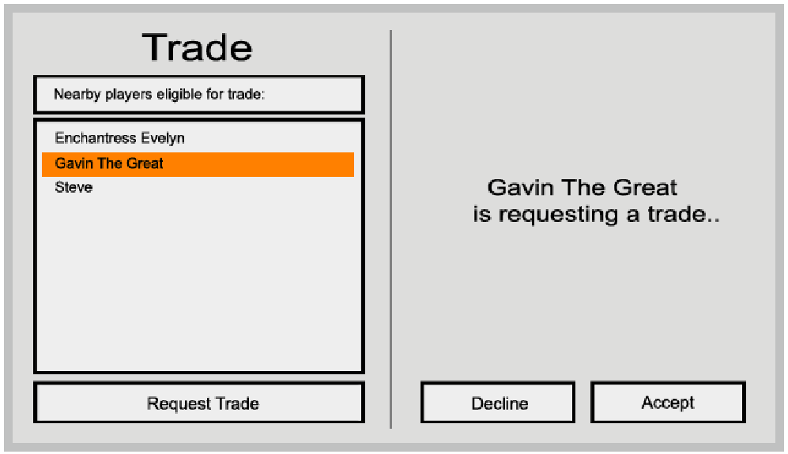

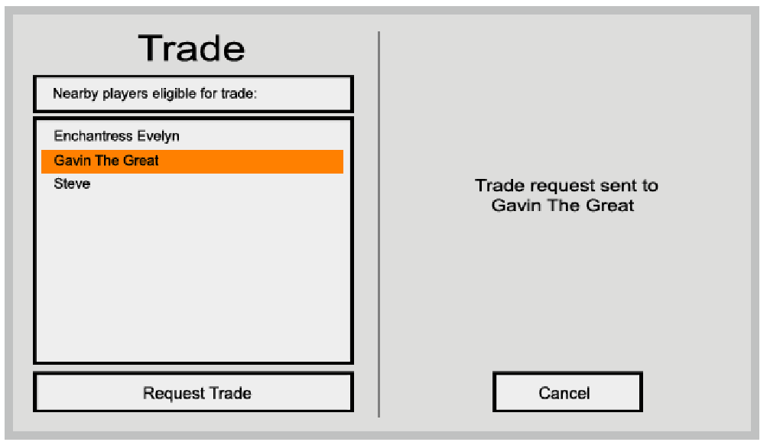

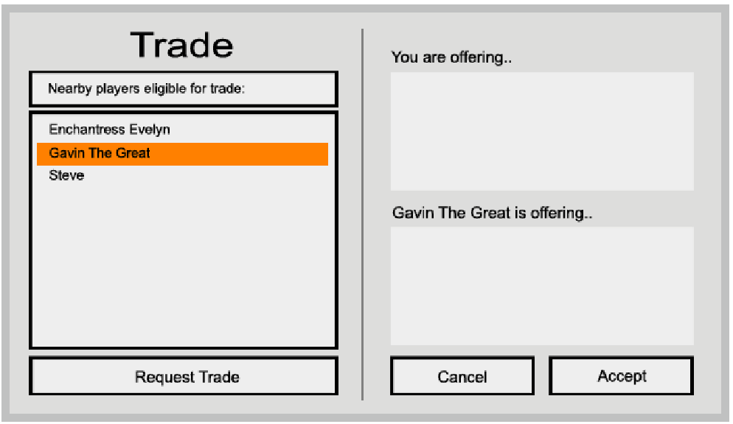

#### Social

Players can add friends via the social window that allow them to see when a player has come online or gone offline, as well as displaying some basic information about the added players’ character. An added friend has two convenience shortcut buttons for ‘Invite to group’ and ‘Send whisper’.

A player may add up to 20 friends.

#### Groups

Players may join groups via the social menu. Once in a group, players may communicate with each other using the /group chat channel.

* Players may only be in one group at a time
* The group leader is assigned to the player who sent the first invite in the group
* A player is removed from a group if he has been offline for more than 5 minutes (and leadership is reassigned to the next player)
* Only one player can be the group leader. The current group leader can award leadership to another player via the social menu
* If the group leader leaves the group, the next player in the group becomes the group leader
* A group is disbanded if it does not contain at least 2 people

Whilst in a group, additional frames are created on the player’s user interface that displays their group members’ health and energy.

A group cannot contain more than 5 players.

Only the group leader may invite players to the group.

#### Chat

The chat box may be used to communicate with other players. Depending on the channel used, different sets of players will be able to see the sent message. To speak in a specific channel, the player must prefix their message with the correct channel code. All further messages will be posted in this channel until the channel is changed again. Some channels can be accessed using shorthand versions of their channel code.

Some chat channels require permissions to speak in, such as the broadcast and system channels.

|  |  |  |
| --- | --- | --- |
| Channel name | Channel code | Who can see the messages? |
| Local | /l or /local | Anyone within 5000 units |
| Group | /g or /group | Anyone who is a member of the party |
| Whisper | /w [player name] or /whisper [player name] | The target player and the sending player |
| System | /sys [player name] | The target player |
| Broadcast | /b or /broadcast | Everyone, everywhere |

#### Miscellaneous

Miscellaneous mechanics and features that don’t justify their own category.

**In-combat**

In-combat is a state flag that indicates whether the player is currently in combat or not. A player is in combat if they have taken or dealt damage to an enemy within the past 15 seconds.

**Accelerated regeneration**

Whilst not in combat, the players’ health regeneration is multiplied by an out of combat multiplier. This value default to 3.

**Inns**

Whilst inside an Inn, the players’ out-of-combat multiplier is quadrupled. Note that the health regeneration stat is still limited by the maximum value outlined in the stats section.

**Fast travel**

Fast travel between key points is available for a small fee. Simply talk to the appropriate NPC and select one of the options.

**Vendors**

Many vendors exist throughout the game that will exchange items for coin. Vendors cannot award the best items available, but will carry most of the basics. Vendors restock over time and change their prices every now and then.

**Threat**

Enemies are more likely to attack opponents they have a high threat against. Threat is generated by dealing damage, mitigating damage and standing in close proximity.

# Art

The artistic style of the game combines a vibrant pre-technology world with a modern interface aesthetic.

The interface is based largely on a game that exists within an anime called Sword Art Online. The design makes use of large one-colour blocks and vibrant highlight colours with a blocky font to make the interface simplistic by highly stylised.

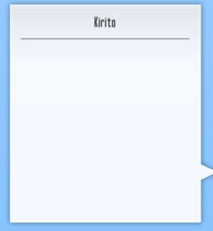  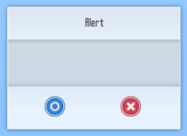

The game world follows a similar theme and uses exceptional emphasis on contrasting colours and themes. Different locations will host very different colour and object sets.

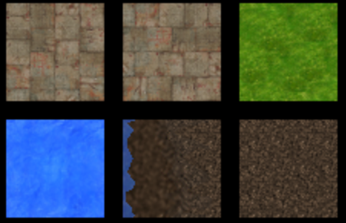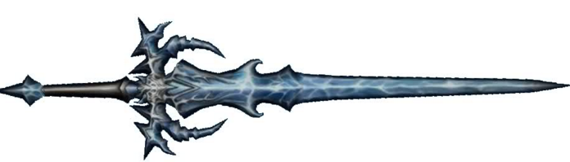

Naturally, a very large number of assets are required to satisfy all of the visual requirements. Additionally, some assets will have multiple variants to reduce repetition amongst areas such as forests. Some examples of the required assets are given below:

|  |  |
| --- | --- |
| Object | Number of variants (inclusive) |
| Tree | 8 |
| Rock | 6 |
| Bronze Sword | 1 |
| Fireball explosion animation | 2 |

# Audio

The audio of the game can be broken down in to two sections: Background music and sound effects. Naturally, both types of audio adhere to the same fantasy RPG theme that the game seeks to convey.

**Background music**

Background music is primarily used to set the tone of the gameplay. Each background track that plays has a clear purpose and well-defined time that it plays. This is listed as follows:

|  |  |  |
| --- | --- | --- |
| Track | Plays | Theme |
| Battle music | When entering battle with an open world opponent | Exciting |
| Boss music | When entering battle with an opponent of significant strength | Dramatic, tense, high stakes |
| Open world | When the player is roaming the open world | Calm |
| Dungeon | When the player is inside a dungeon | Calm, eerie |
| Dungeon battle | When the player is battling an enemy within a dungeon | Dramatic |
| Launch | The opening soundtrack when launching from the splash screen | Exciting, dramatic |
| Menu music | The soundtrack that plays after the launch soundtrack whilst on the menus | Calm |

**Sound effects**

Sound effects can occur from two locations: The user interface and the game world.

Sound effects that occur on the user interface are primarily used as a form of feedback that help the user quickly know if a button has been pressed or hovered over. This can be disabled or reduced in volume in the options menu should the player desire it.

|  |
| --- |
| User interface sound effects |
| Button hover |
| Button pressed |
| Check box checked / unchecked |

Game world sound effects are used to add to the immersive-ness of the game. It only seems right that launching a fireball would result in a fiery sound effect after all.

Effects are divided up in to groups that allow the user to modify specific audio channels. Alternatively, the master volume will modify them all.

|  |  |
| --- | --- |
| **Game world sound effects**  **(Some effects will have multiple variations)** | |
| **Ambience** | **Effects** |
| Water dripping | Footsteps (2 feet) |
| Rushing water | Footsteps (4 feet) |
| Water fall | Spell casts (many variations) |
| Spooky whispers | Level up |
| Cave wind | Weapon swing/fire (many variations) |
| Cave ambience | Weapon collide (many variations) |
| Birds | Quest accepted |
| Wind | Quest completed |
| Magic humming | Roar |
| Bushes / trees rustling | Equipped / unequipped item |
| Bubbling potions | Mining |
| Forge effects | Crafting |
| Creaking wood | Foraging |

# User interface

### General information

The user interfaces have been designed with the understanding that the user will be able to utilise a large number of clickable buttons via the mouse or keyboard in any one game state. Transitions between interfaces may or may not include animations depending on the current state and target state.

### Interfaces

**In-game interface**

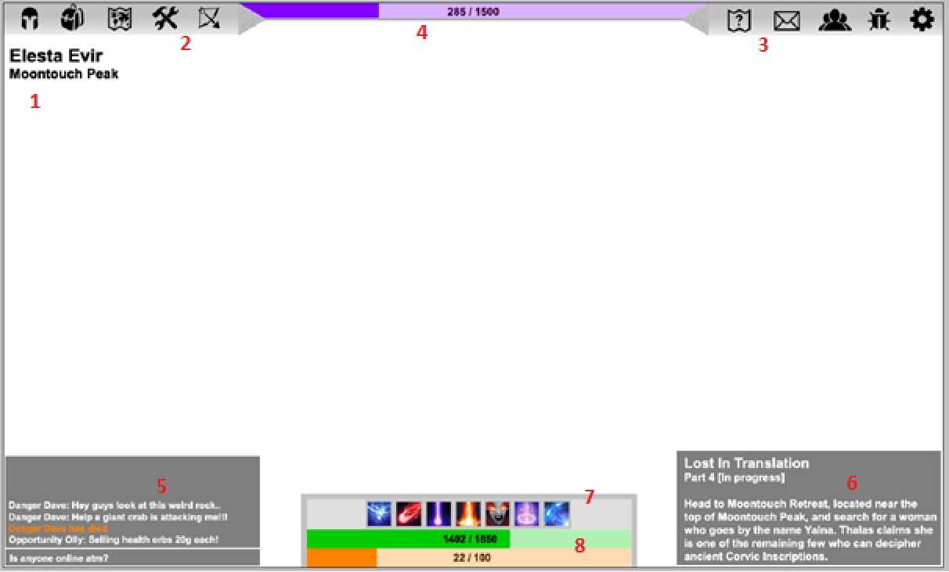

|  |  |
| --- | --- |
| **Index** | **Description** |
| 1 | The continent and zone name the player is currently in. |
| 2 | The left menus. Home to the character, inventory, map, crafting and skills menu buttons. |
| 3 | The right menus. Home to the quests, trade, mail, social and options menu buttons. |
| 4 | The experience bar. Tracks how much the players experience completion. |
| 5 | The chat window. Allows communication amongst players. |
| 6 | The ‘tracked quest’ text. A single quest may be displayed on screen in this location so that the player does not have to constantly reopen the quest log to remind themselves of what they are doing |
| 7 | The skill bar. Contains up to 7 active skills. |
| 8 | The health and resource bars. Tracks the player’s current and maximum health and resource values. |

**In-game sub menu interface**

This image demonstrates the position and backdrop for each menu that is accessible from the in-game user interface. The actual content of each sub-menu varies greatly, but should be expected to be a combination of text and images that are queried from the server each time the menu is opened.

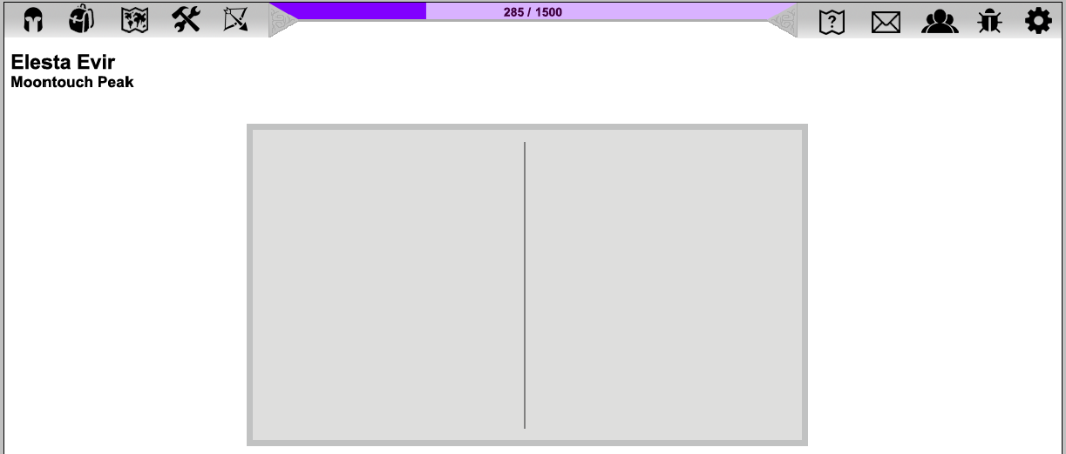

For example, opening the character sub-menu will query the server for the players character information. Such information is likely to displayed in a format similar to below:

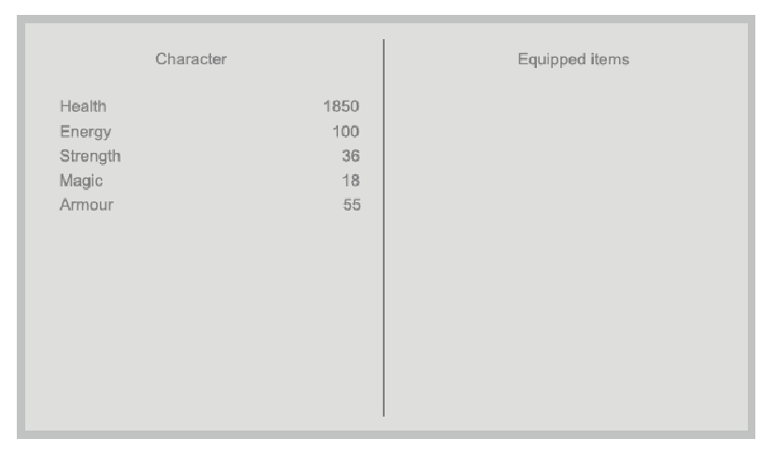

Note that this is merely an example and will be further refined and contain more information at a later date.

**Main menu interface**

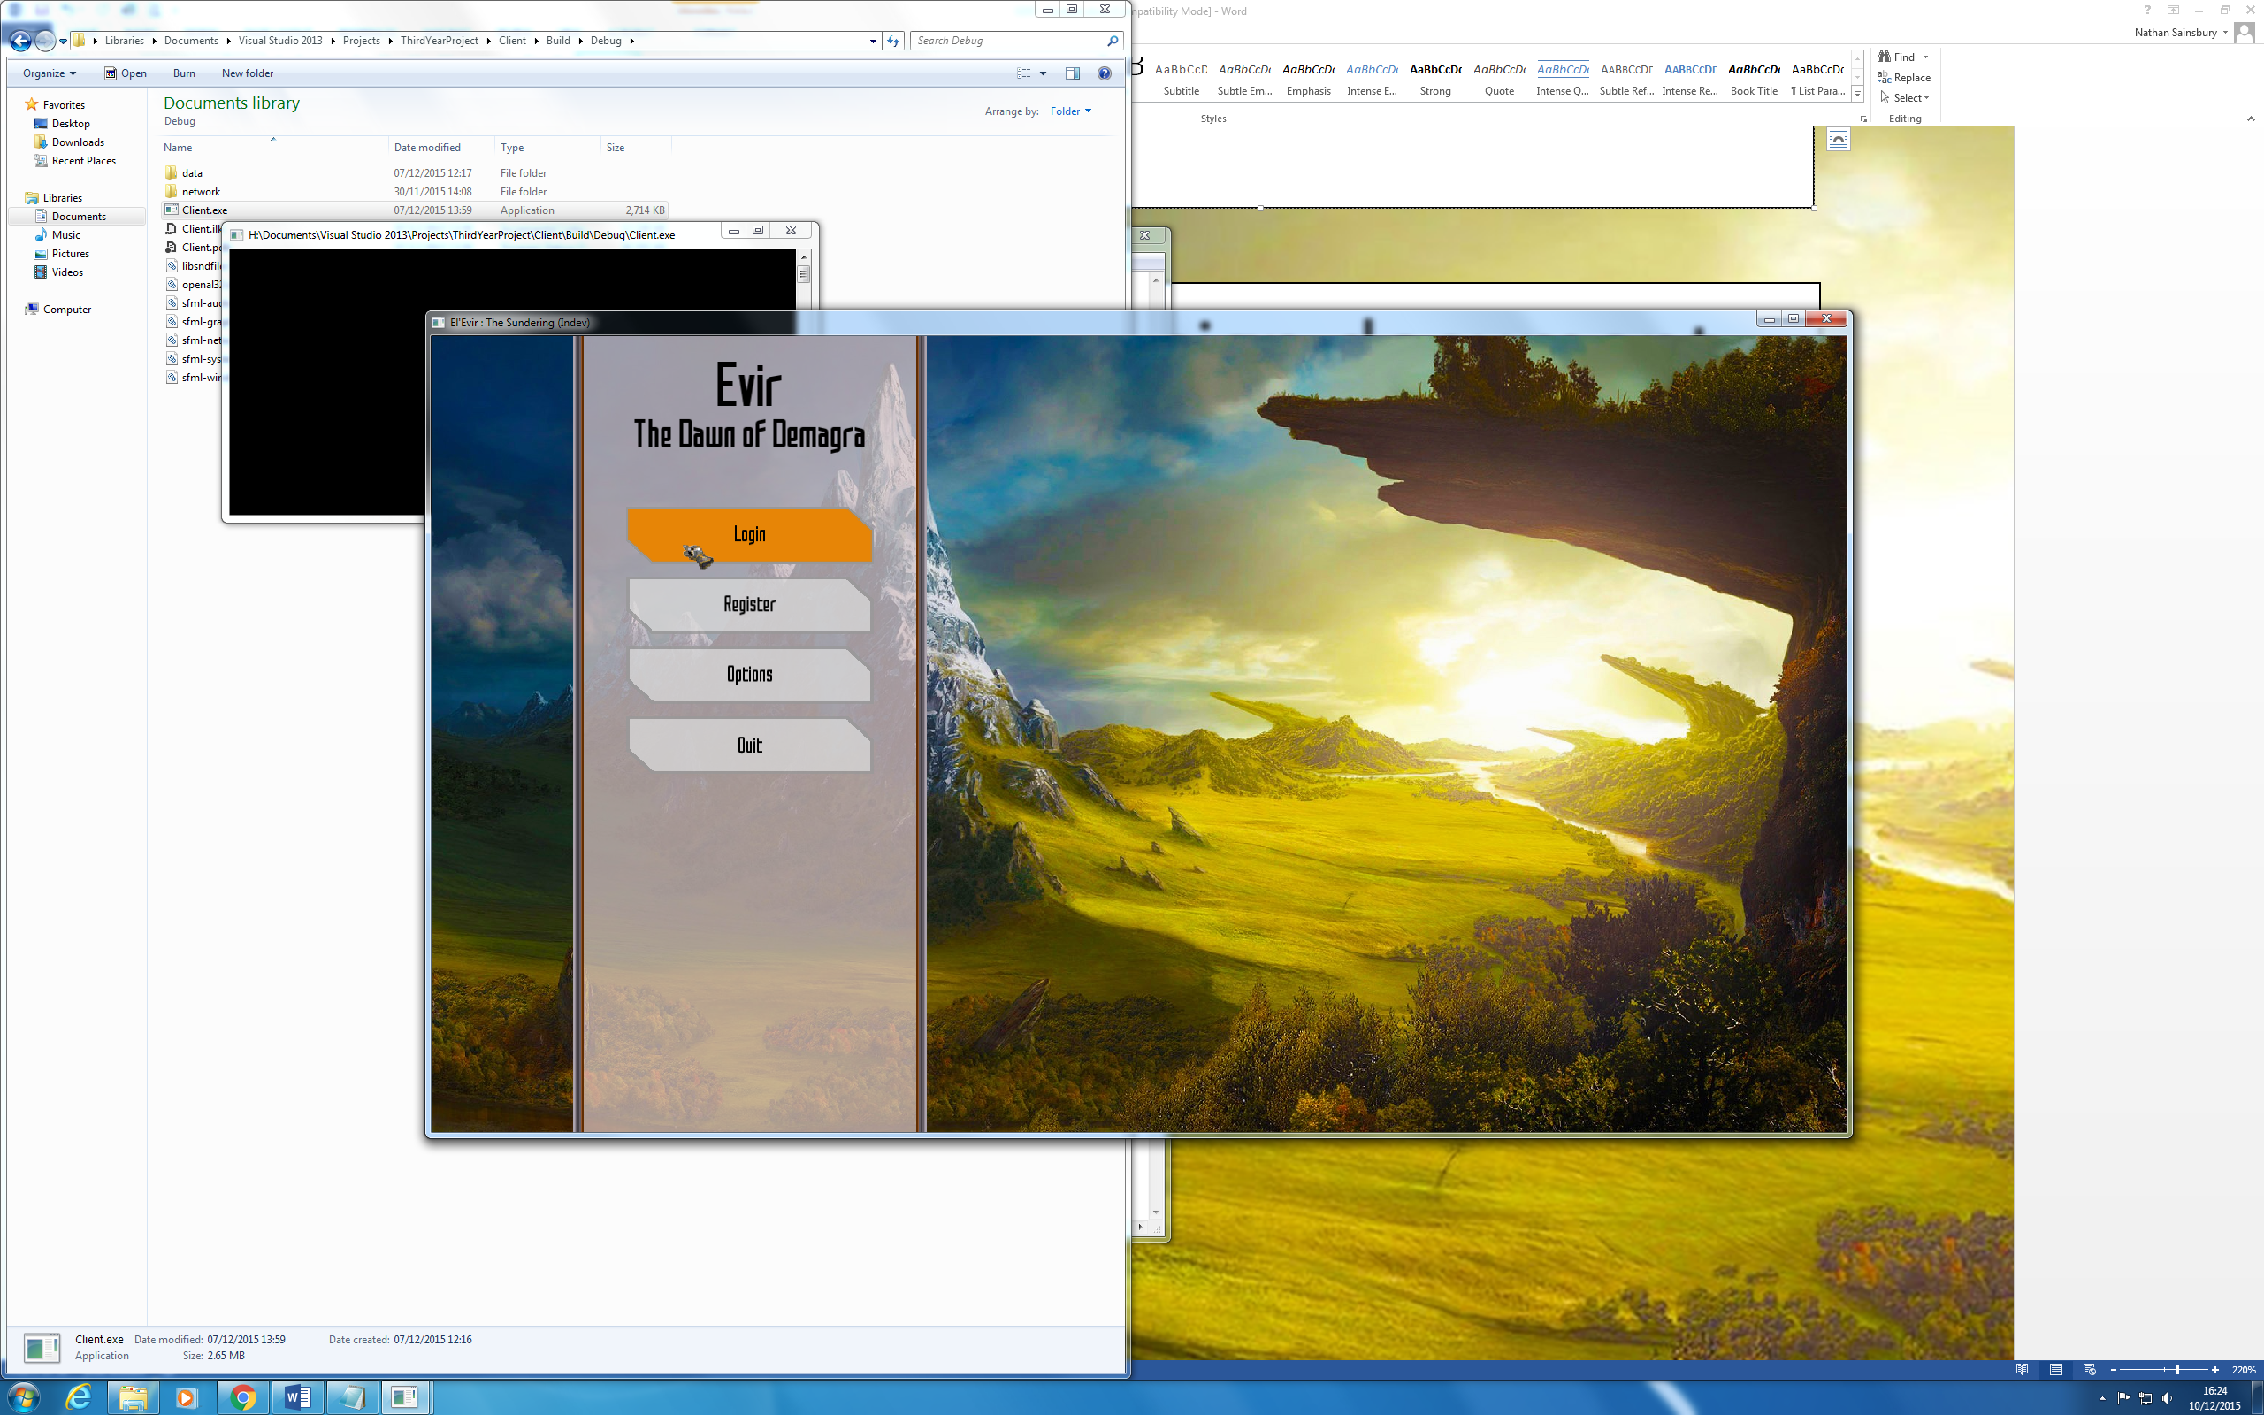

The main menu sub-menus can be revealed by clicking their relevant buttons. Revealing one sub-menu will hide any existing sub-menus. Sub-menu content is subject to change.

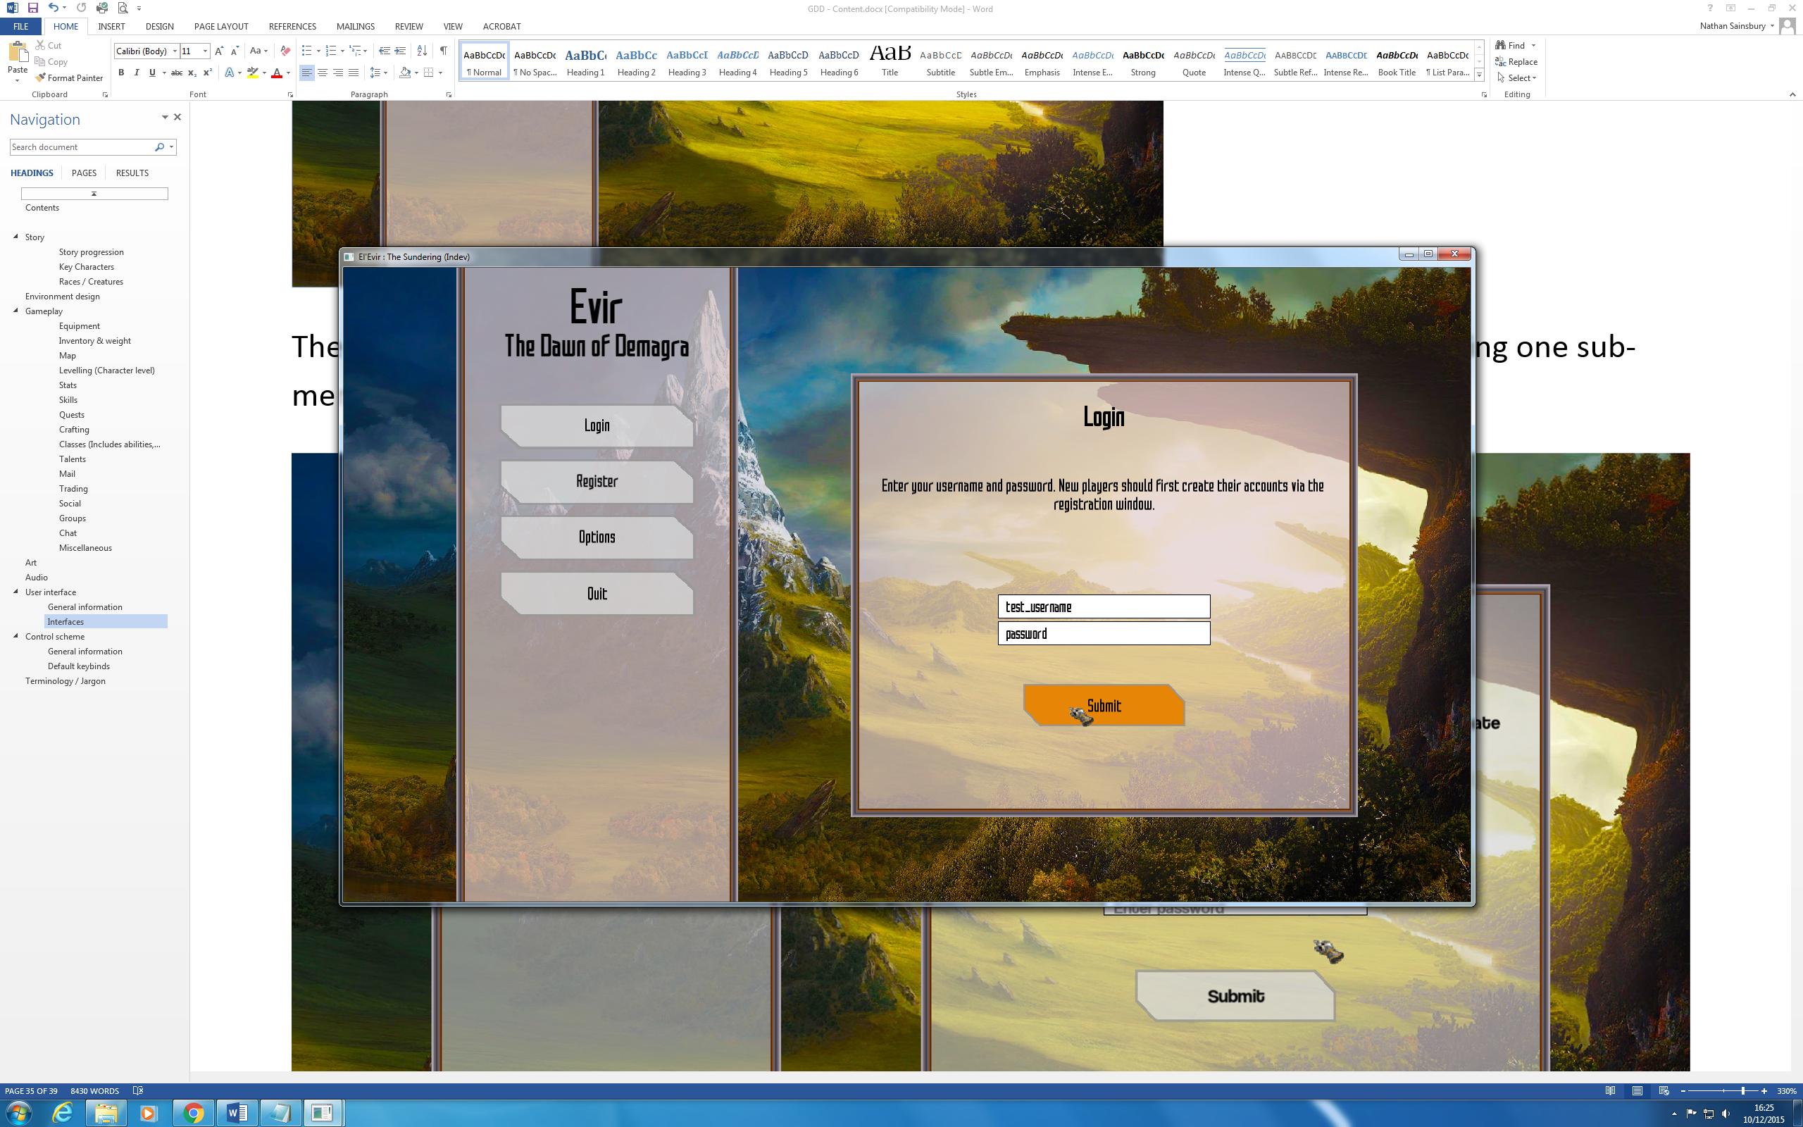

**Realm selection menu**

The realm selection menu is mostly dynamically generated and includes a list-box of all the available realms and a small amount of information about them. Each entry is a clickable button that will attempt to log in to the target realm on click. Clicking the back button from here will bring the user back to the main menu.

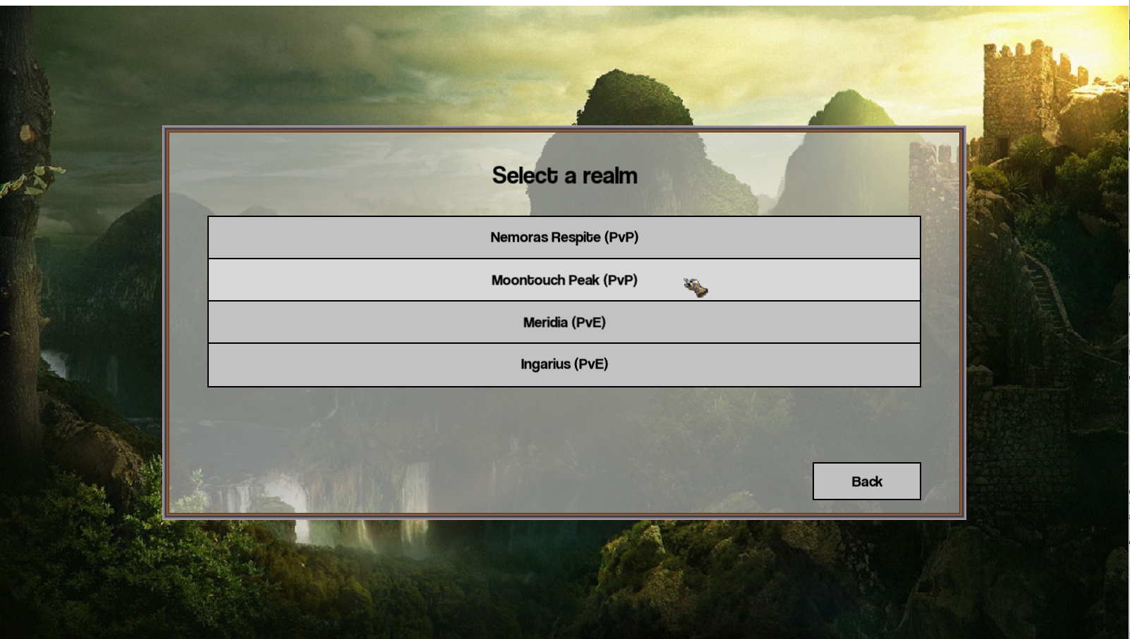

**Character selection menu**

The character selection menu is also mostly dynamically generated using the logged in accounts’ character listing. Each character is a clickable button that will attempt to log in to the game using that character on click. Clicking the back button from here will return to the realm selection menu.

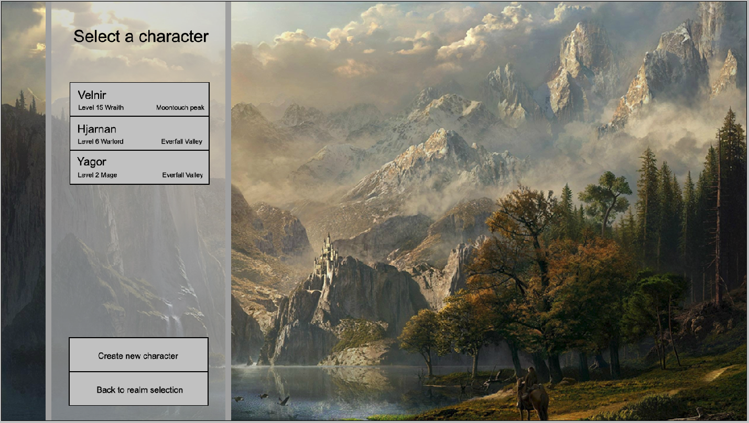

**Character creation menu**

This is the base of the character creation menu. The content of the character creation will change as time goes on and thus has not been listed.

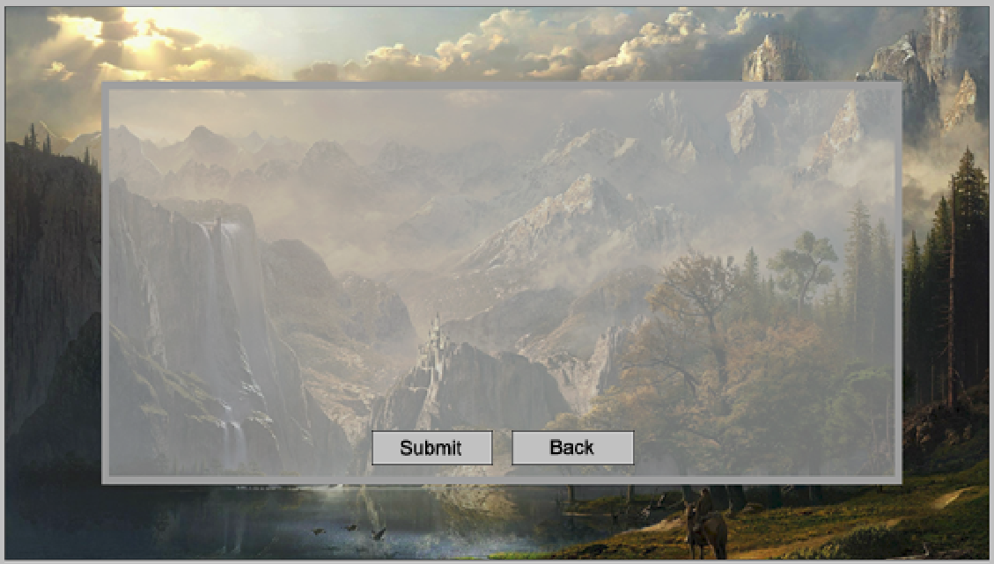

# Control scheme

### General information

The game makes use of the same input controls that can be expected of almost any computer game: A mouse and a keyboard. No other forms of input will be supported.

Upon first launching the game, it will automatically configure itself to operate using a default set of keybinds. Due to the likelihood of there being more actions that require binding than there are available keys, each game state will operate using its own set of keybinds. In some cases, these keybinds can be modified by the user via options menus to provide a more customised gameplay experience. The following is a list of which keybinds sets can be modified, and by what means:

|  |  |  |
| --- | --- | --- |
| **Game state** | **Keybinds modifiable?** | **How?** |
| Splash Screen | No |  |
| Main Menu | No |  |
| Realm Selection | No |  |
| Character Selection | No |  |
| In Game | Yes | In-game options menu |
|  |  |  |

Any customisations made to the keybinds will be saved to a local profile on the computer. These keybinds can also be modified directly by editing the local profile using any standard text editor. Keybind configurations are validated each time they are loaded in to memory and receive a “best-effort” correction for any invalid entries.

### Default keybinds

The following is the default keybind configuration for each game state.

**Splash Screen**

No keybinds

**Main Menu**

|  |  |
| --- | --- |
| **Action** | **Keybind** |
| Toggle login sub-menu visibility | 1 |
| Toggle register sub-menu visibility | 2 |
| Toggle options sub-menu visibility | 3 |
| Close the game | Esc |

**Realm Selection**

|  |  |
| --- | --- |
| **Action** | **Keybind** |
| Logout and return to the main menu | Esc |

**Character Selection**

|  |  |
| --- | --- |
| **Action** | **Keybind** |
| Return to the realm selection screen | Esc |

**In Game**

|  |  |
| --- | --- |
| **Action** | **Keybind** |
| Move forward | W |
| Move backward | S |
| Turn left | A |
| Turn right | D |
| Cast ability 1 | 1 |
| Cast ability 2 | 2 |
| Cast ability 3 | 3 |
| Cast ability 4 | 4 |
| Cast ability 5 | 5 |
| Cast ability 6 | 6 |
| Toggles the character window | C |
| Toggles the inventory | I |
| Toggles the world map | M |
| Toggles the crafting window | R |
| Toggles the skills window | K |
| Toggles the quest log | U |
| Toggles the mailbox | L |
| Toggles the social window | O |
| Toggles the bug report window | B |
| Toggles the options window | P |
| Open chat box / Send chat message | Enter |
| Interact | Left click |
| Attack | Right click |

# Terminology / Jargon

|  |  |
| --- | --- |
| Keybinds / Hotkeys | The binding of a keyboard key, mouse button or scroll wheel event to an in-game action. For example, an ‘onPress’ event occurring on the ‘w’ key can be keybound to a ‘move_forward’ action. |
| Cooldown | A term given to the duration between using an ability and the next time it becomes available. An ability that can only be used once every 5 seconds is said to have a cooldown of 5 seconds. |
| Buff | An effect that increases the power of the target that it is applied to in some form. For example, a physical damage buff increases the targets physical power by a set value. |
| Debuff | An effect that decreases the power of the target that it is applied to in some form. For example, a movement speed debuff decreases the targets movement speed by a set amount. |
|  |  |
| Vendorable | An item or object that can be sold to a vendor in exchange for currency |
|  |  |
|  |  |

### 12.4 Technical design and development appendices

**12.4.1 Client UML extract (Full diagram on disk)**



**12.4.2 Server UML extract (Full diagram on disk)**

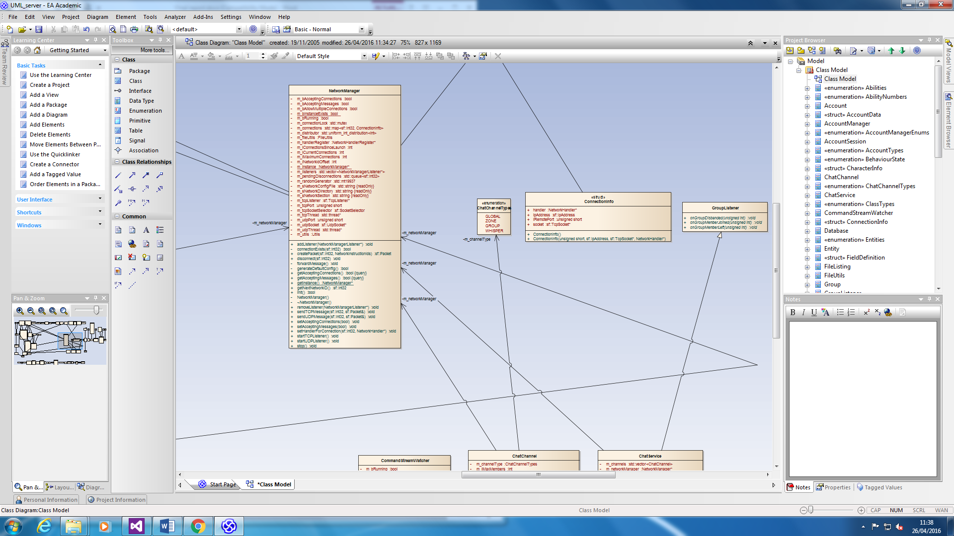

**12.4.3 Style guide (full)**

**Style guide**

**Naming rules**

Variables and parameters shall adhere to the following style rules:

* Variable names shall be given in lower camel case
* Member variables shall begin with “m_”
* Booleans shall be prefixed with “b”
* Integral values shall be prefixed with “i”
* Floating point values shall be prefixed with “f”
* String values shall be prefixed with “s”
* Common variable types such as a vector or matrix may implement their own logical prefix, but will not overwrite any existing prefixes or use an underscore character

Function styling rules:

* Function names shall be given in upper camel case

Class and structure rules:

* Classes and structure names shall be given in upper camel case

Miscellaneous:

* Brackets shall exist on their own lines, except in situations where a very large number of if statements follow one another
* If a situation occurs where this document does not provide a rule, the Google code style rules document is to be followed instead

**File templates**

Header files (.h)

Each header file should adhere to the following stylistic rules:

* A comment describing the purpose of the class must be situated at the very top of the class
* The comment must contain an author tag
* The file must include an all-capitals inclusion guard using #ifndef, #define immediately following the class description comment. The guard must end with _H
* Inclusions must follow the inclusion guard and may be given in any order, preferring to group related inclusions where appropriate
* The class or structure must then be defined as an upper camel case version of the inclusion guard without the _H appendix
  + Classes
    - A class header file should specify its access levels in the order private, protected, public
    - An additional public section may be added at the top of the class and may contain enums only
  + Structs
    - A structure should contain no access identifiers
    - Constructors for the header must be given after all member variables
* The class must end with an #endif statement

C++ files (.cpp)

Each C++ file should adhere to the following stylistic rules:

* Only one inclusion should ever be present in the cpp file, and that is the inclusion of the matching header file. For example, the cpp file “MyVector” will only include “MyVector.h”.
* The inclusion shall appear at the top of the file.
* If any static variables must be declared, this must occur immediately following the inclusion.
* All constructors regardless of access level are declared following the static variables
* All destructors regardless of access level are declared following the constructors
* All other functions may be declared in any order following the destructors
* Particularly large classes may be divided using a line of comment characters “/” with a comment describing the division immediately below

**Documentation**

Generation

Documentation shall be generated as a HTML document using the Doxygen tool.

Formatting

Comments are formatted according to the following rules:

* Class/struct comments
  + Class/struct comments shall begin with the following characters on their own line: “/**”
  + A class comment shall define the responsibility or the purpose of the class. Further comments may optionally be added to expand on internal functionality.
  + The final line of the comment shall be an author tag @author and a comment closing character set “*/”
* Function definition comments
  + Function definition comments shall begin with the following characters on their own line: “/**”
  + The description of the function will be given immediately following these characters
  + Parameter definitions shall follow the description, beginning on a new line and using the tag @param
  + Optional parameters will contain the flag (Optional)
  + Return values shall be defined after all parameters using the @return tag
  + The comment shall end with the following characters on the same line as the last relevant tag: “*/”
* Variable/Enum comments
  + Variable and enum comments are optional and will occur on the same line as the enum or variable declaration using a double slash “//”
* Implementation comments
  + Implementation comments shall begin with a double slash “//” and shall reside on their own lines

**12.4.4 Style guide example code**

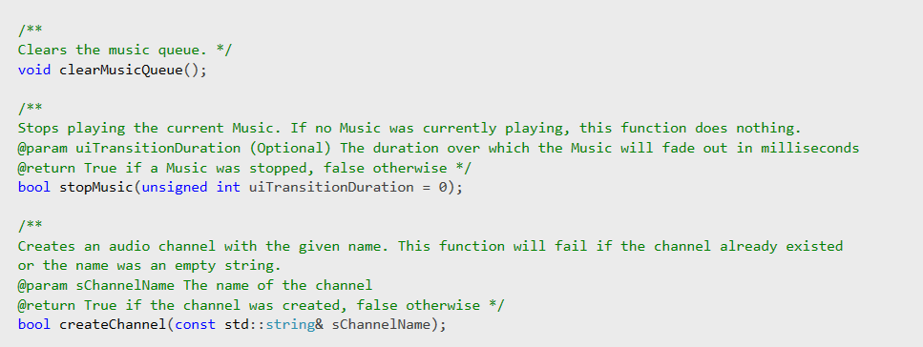

**12.4.5 Style guide example class**

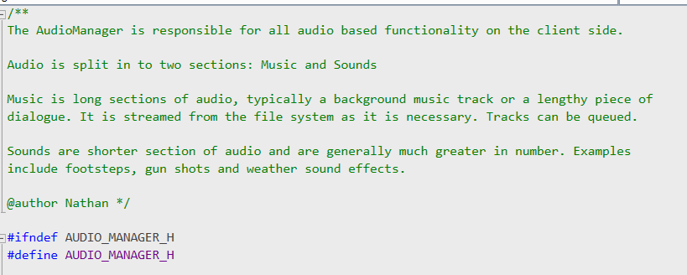

**12.4.6 Doxygen generated documentation example**

